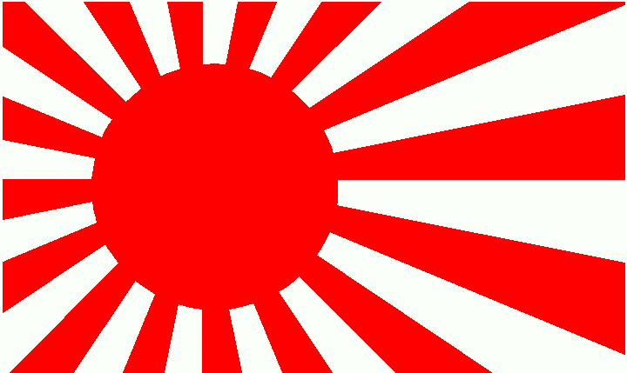**Why Did Japan Wish to Invade**

* China refused to acknowledge that Japan was the dominant regional power or treat them with the same respect that was given by the Western Powers.
* China still referred to the Japanese in official communications as dwarf bandits or wokou.
* Japan had invested ¥5.9 billion in China
* Japanese businessmen were murdered at higher rates than Westerners,
* Commercial treaties were violated. Between 1925 and 1931, the Chinese began encouraging the boycott of Japanese goods which elicited increasingly aggressive responses.
* In 1928, the Nationalists demanded that the foreign powers pay customs duties on items imported or exported by rail. The USA agreed and the other powers followed. Japan refused until the end of 1930. China began building their own railway lines in Manchuria to compete with the Japanese, sparking a tariff war.
* Increased tariffs allowed China to increase its customs revenue from 46 million yuan to 385 million yuan – even in the midst of the Depression.
* By 1931, Chinese and Japanese leaders increasingly viewed their goals as mutually exclusive: only one country could dominate Asia.
* China was as determined to reverse the outcome of the First Sino- Japanese War as Japan was to reaffirm it. In the short run, China could do little, while Japan did far too much. China was becoming a bigger trading partner in Manchuria than Japan, this meant in 1931 that was comfortable in announcing a policy in 1931 the eventual nationalization of the Japanese railways.
* Japan owned the South Manchurian railway, to protect its investment it stationed an army in the province.
* It is estimated that a quarter of Japanese tax revenues came from the Manetsu Corporation which controlled Japanese investments in the region.
* Japan was critically short of raw materials.
* After clashes between Chinese and Korean farmers in Wanbaoshan the Japanese stirred up anti-Chinese rioting in Korea which left 100 Chinese dead, with no intervention by the Japanese police.
* In June 1931, Chinese forces killed Captain Shintaro, who was conducting clandestine reconnaissance for a possible Japanese strike (from the Kanto army) against the Soviet Union.
* Japan feared a seemingly resurgent USSR, it feared that the Soviets could assist the Communists to power, in return for territorial concessions in Manchuria. Japan had hoped to stabilise Manchuria, in the assassination of Zhang Zoulin in 1928 and the replacement with the more pro-Japanese Zhang Xueliang. This had not worked. In 1929, Zhang Xueling tried to confiscate the Tsarist possessions by taking over the Chinese Eastern Railway. The Soviet Union sent 100,000 men to retake the railway. The Nationalist government did not intervene. .Japan felt that it was only mirroring the Western Powers in acting militarily to protect an economic investment.
* Unlike other nations, the Japanese Military had always been the outlet for radicalism. There was no outlet as there was in the west for activism through the Trade Unions or Universities. The assassination attempt on Hamaguchi Osachi, showed that no politician could stand in the Armies way. The army (dominated by radical societies) who wished to formalise their empire in China. In addition, the Japanese constitution made the military powerful. The army and navy ministers had to come from the military and were part of all cabinets. If the military withdrew its ministers, the government collapsed. Japanese leaders were bereft of a grand strategy or a clear idea of problems caused by Japan’s annexation of Manchuria could lead to problems. Those who objected were assassinationed by army officers. As a result, by 1931 the civilian government was no longer able to command the military or control its spending. From 1932 to 1936 the prime minister’s position was held by admirals. The Japanese army failed to realise that in attempting to increase its power it was ignoring the advantages Japan had as a maritime power – and that it never could be a continental force. Publicly the Japanese professed a desire to improve co-operation and prosperity within the region. Privately they wished to carry out experiments that were too radical to be trialled at home.
* The perceived failures of the western democracies militarily in the First World War and then economically during the Great Depression, meant that extreme nationalism or Communism were seen by many as the only alternatives. Japan was reliant on the export of luxury goods and while producing a phenomenal amount of food on a small acreage, it could not cope with the drop in the price of agricultural exports. Farmers were forced to sell their daughters and there were complaints of cannibalism in the Japanese countryside. There was widespread industrial unrest for the first time. Japan needed a distraction from these domestic problems. Japan’s main trading partner was the USA, the increase in tariffs by America on Japanese goods effectively meant that Japan would be unable to trade its way out of the Depression, this had the dual effect of discrediting the Japanese civilian leaders who had favoured co-operation with the West. The Japanese were far poorer than its European counterparts, its population was growing by a million each year. Previously, most Japanese immigrants had gone to the USA, but this was stopped by the Depression. It needed room for expansion and Manchuria was described as the granary of Asia. The collapse of international trade meant that there was now no incentive for the Japanese to act as good international citizens.

Economic Problems in Japan

Political Divisions in Japan

Nationalism

WHY DID JAPAN INVADE MANCHURIA IN 1931?

Alleged Chinese Provocations

Foreign Actions

Strategic Miscalculation

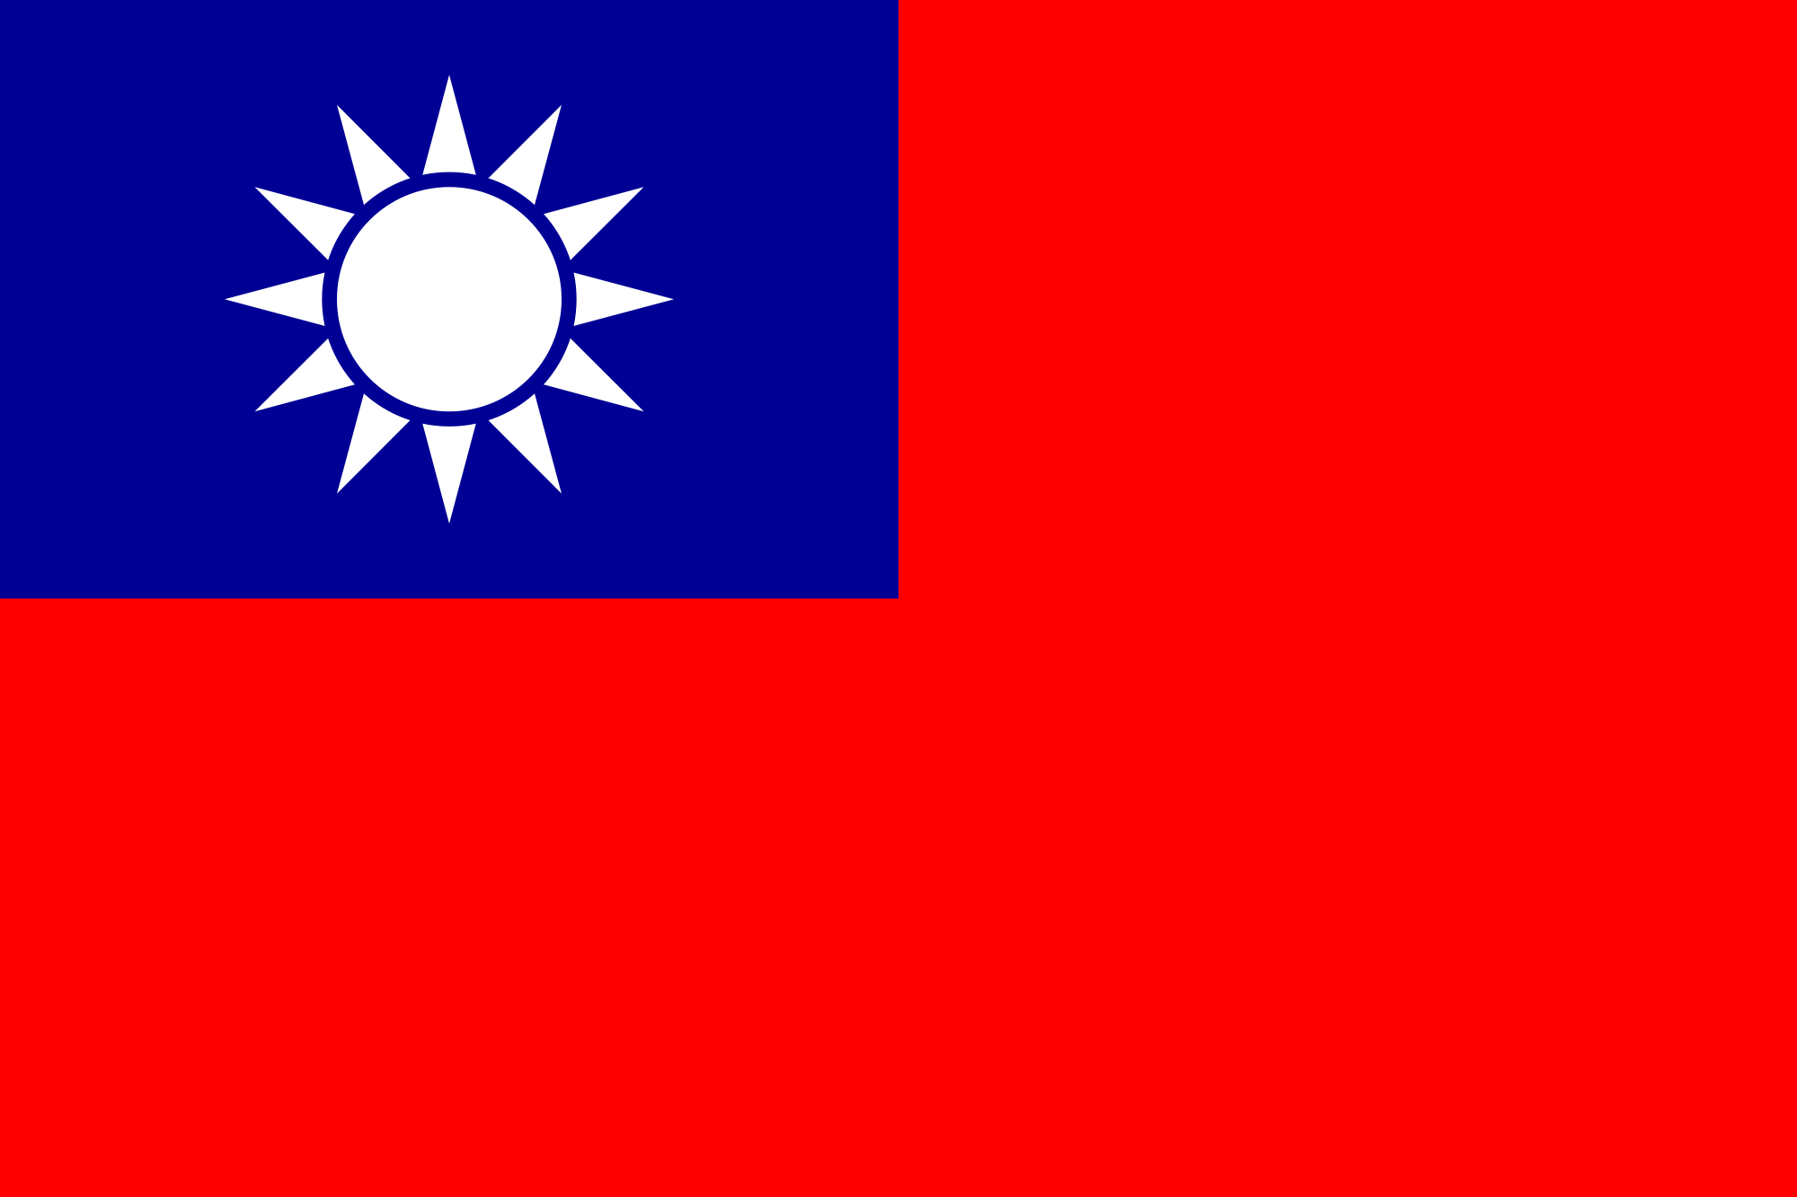What Did China Do?

* On September 18, 1931 a Japanese force attempted to blow up the Dairen express. They then blamed Chinese bandits and occupied Mukden. It was a very minor explosion that did not even prevent trains from running. It was stationed very near a Japanese barracks.
* The Mukden incident was not carried out by the Japanese Government or even the Japanese military high command in Tokyo. This was done by the Kanto Army, which was permanently situated in Manchuria and was semi-Autonomous. This is not to say that there were not large sections of support for the Kanto Army’s actions within the civilian government and almost complete support from the army. In December 1931, the Japanese Government collapsed due to its inability to control the army in ceasing the occupation. Two days later the Chinese government collapsed.
* They claimed that Manchuria was in anarchy and ordered Japanese soldiers to restore law and order. They quickly occupied most of the provinces in the district.
* The Chinese leader Chiang Kai Shek was unwilling to risk his ill-equipped soldiers even though they outnumbered the Japanese as he was involved in a Civil War with the Communists, who had been forced into China’s interior in 1927.
* His rival Wang Jingwei opted to provide token resistance while referring the matter to the League of Nations. He was offered bilateral talks with the Japanese foreign ministry. Eventually Wang betrayed Chiang Kai Shek and become the ruler of the Japanese puppet state that was created after the beginning of the Sino-Japanese War in 1937.
* The Nationalist Government (KMT), had not exerted any control over the area since the birth of the Republic in 1911. It had been under the control of the warlord Zhang Zuolin, who was a former bandit who had built up his own private army called the Fengtian, which numbered approximately 300,000 by the end of the 1920’s. Zhang had created his own private kingdom, taking advantage of Manchuria’s isolation; though Zhang pledged alliegance to China, he practised almost complete indepenedence . His son Zhang Xueliang, had recognised Chiang Kai Shek has the ruler of Manchuria (he wished to be second in command of all of China), but he also demonstrated a large deal of independence having already withdrawn his troops before Chiang’s order to do so had arrived. Zhang (an opium addict) was more concerned about the Soviet Union than Japan and was considered to be pro-Japanese having trained with the Japanese army in the 1920’s and becoming an officer.
* In January 1932, the Japanese army attacked Shanghai, using a brawl that had taken place within the city between Buddhists and the Japanese as a pretext. In this instance the navy was also involved – in order to justify its large budget. In May 1932, the Japanese Prime Minister Tsuyoshi was assassinated (after two previous failed attempts) and the military took control of the government through Admiral Makoto.

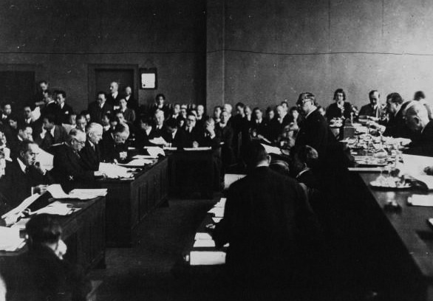

**The British and French Position**

* None of the League members were particularly interested in Manchuria. It was too far away and the Washington Naval Conference had effectively decided that the Pacific was in the Japanese and American sphere of influence. Both believed that Manchuria would be better off under the Japanese.
* All Powers were more concerned with coping with the Great Depression and preparing for the upcoming disarmament conference.
* Britain was in economic chaos after it recently removed itself from the gold standard. Privately it hoped for conflict between Japan and the Soviet Union. It preferred that Japan expand into China rather than its own empire.
* France was worried about the increasing opposition that was occuring in Indo-China (Vietnam) and its own internal instability.
* Even Stalin was not interested despite Manchuria being a long standing area of interest for Russia. He even offered to sell the East-Manchurian railway to the Japanese

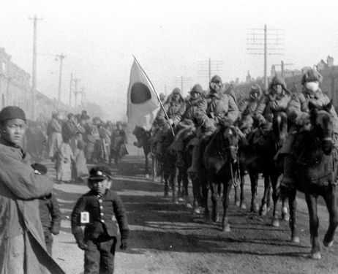What did the League Do?

* On September 30, the Council met (without representatives of China and Japan) and ordered the Japanese to withdraw behind the railway line. The Japanese responded by bombing Jinzhou, which saw the League setting 16 November as an ultimatum. The Japanese stated that they would only deal with Chinese directly.
* The League had believed Chiang Kai Shek when he had previously assured them of China’s stability in order to legitimise his own rule. They did not realise how weak China was or the claim to power that Zheng Xupling had to the area.
* The Japanese continued to push forward in Manchuria. In December the League appointed a commission of inquiry under the Earl of Lytton. The commission was a Japanese suggestion designed to allow them further time to complete their conquest.
* In March 1932 the Japanese proclaimed that Manchuria was now Manchukou and was to be ruled by the former emperor Puyi. They attempted to extend the new states borders pushing to the point where the Great Wall meets the sea.
* After protests broke out in Shanghai, Japan attacked the city. The Chinese government offered resistance, but was eventually forced to demilitarise the area in May.
* Japan argued that by separating Manchuria from the chaos of China’s politics and internal wars, it was bringing peace and stability to the people who lived there.
* Lytton arrived in Manchuria in March 1932 In October 1932, (a full year after the Mukden incident) he presented his report. It agreed that Japan had special interests in China and in Manchuria in particular. It stated there had been a bombing in Mukden, although it did not investigate who had carried this out. He noted that there had been no Manchurian uprising for independence despite Japanese claims. The report continued that the Japanese army had gone beyond defending its railway interests by occupying the entire province of Manchuria. It suggested Japan should not have used such aggression. The report failed to outright condemn Japan for the invasion although Japan had clearly violated many of the articles in the Covenant of the League of Nations. Britain, France and Italy half-heartedly protested about Japanese actions against China, but did little else.
* It was not until January 1933 a special assembly that the League met to discuss the report. The League then asked Japan to remove its troops again. Japan then left the League and began negotiations with China, which saw it retain Manchukou as well as gaining control of a large demilitarised zone in the Hebei province, putting it within striking distance of Beijing.

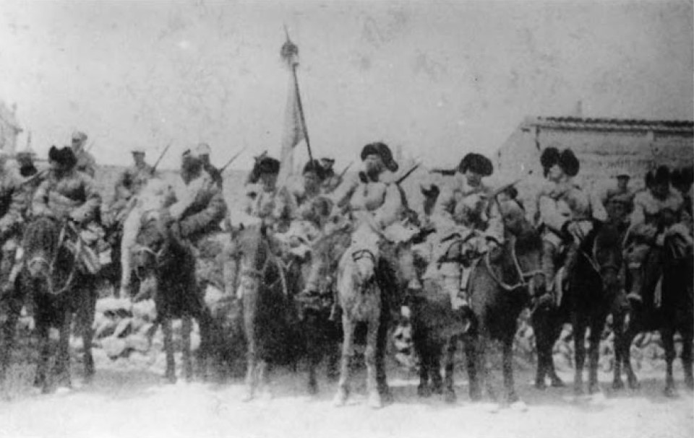In 1933, the Japanese attempted to create what they framed as the Asian Locarno, when they attempted to introduce the Security Pact of the Pacific. This was a Japanese attempt to gain international legitimacy for Manchukuo, outside the League of Nations. They argued the world organisation was not equipped to provide a lasting peace, with the absence of the USA, Soviet Union and Germany. The Asian Locarno met with little enthusiasm from any other powers and Japan then turned to the Greater Asian federation. This had a long history of thought in both China and Japan, but now Japan wished to take the lead in forming a new pan-Asian identity premised upon an ideology of cooperation for the welfare of the whole community, a system that would discard the West’s defective notion of individualism. It has to be remembered that these ideas were from the Japanese foreign office and not the military, and even then they were prefaced on the premise that Japan would retain its gains in China.

|  |  |
| --- | --- |
| Practice your response to the following question: **How far was the response of the League of Nations to the Japanese invasion of Manchuria justified?** | |
| For | Against |
| 1. | 1. |
| 2. | 2. |

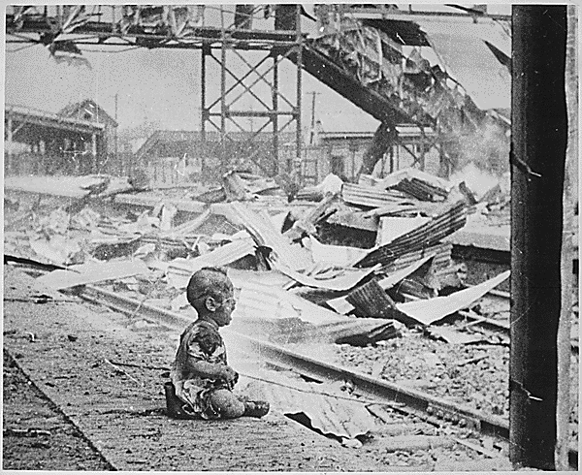Consequences?

* It was a deathnail for collective security. Economic sanctions were proven ineffective as long as the USA remained outside the League. The only nation that could have sent enough troops to prevent the takeover was the USSR, who was not a member. Japan had too large a navy to risk an invasion. At any rate no country had the will or ability to assemble an army to confront Japan. The Chinese had followed the spirit of the League of Nations, allowing a force of 11,000 to occupy Manchuria (this was partly to save troops to fight the Communists). Non-Aggression was exactly what the League was founded to support. Japan was now treated as an equal of the Western Powers. The country became a self-created outcast, which only fuelled nationalism and militaristic chauvinism. The Western Powers protected Shanghai, but China turned to Nazi Germany. The Washington Treaty lapsed and Britain began preparing defences in Singapore and the USA began to rebuild
* From an economic standpoint the annexation of Manchuria and Jehol was useful for Japan and it would not have been able to wage the Second World War without it. Japan invested heavily in the area and nationalised industries. Manchuria accounted for 90 percent of Japan’s oil, 70 percent of its iron, 55 percent of its gold, and 33 percent of its trade. By 1943 Manchuria produced 49.5 percent of all Japanese coal, 78.2 percent of its electricity, 87.7 percent of its pig iron, 93 percent of its steel, 66 percent of its concrete, and 99 percent of its oil. By 1945 Manchuria had a per capita income 50 percent higher than the rest of China and became the most industrialized part of Asia outside the Japanese home islands, outproducing even the Yangtse Delta, long the centre of China’s modern economy. Japanese investment into the newly conquered area contrasted with the solutions of most Western nations and meant that the Japanese domestic economy began a period of recovery –only increasing support for the new military government. Despite improved economic conditions, Japan did not have the economic base to launch a full-scale war against China. The percentage of GDP spent on the military went from 6.55% in 1933 to 46% in 1936. Combined with increased social spending at home, the military build-up resulted in rampant inflation, which meant the economy had stagnated in 1937, before collapsing completely in 1941.

* After the conquest of Manchuria, Japan moved to cement its gains and prepare for a full-scale invasion of China. By May 1933, Japan had established the Great Wall as their line of control and began raids into Hebei to force Chiang Kai-Shek into a truce. Eventually he agreed to remove all troops from Hebei. To facilitate a larger invasion into China, Japan took the opportunity to purchase the Soviet rail lines in 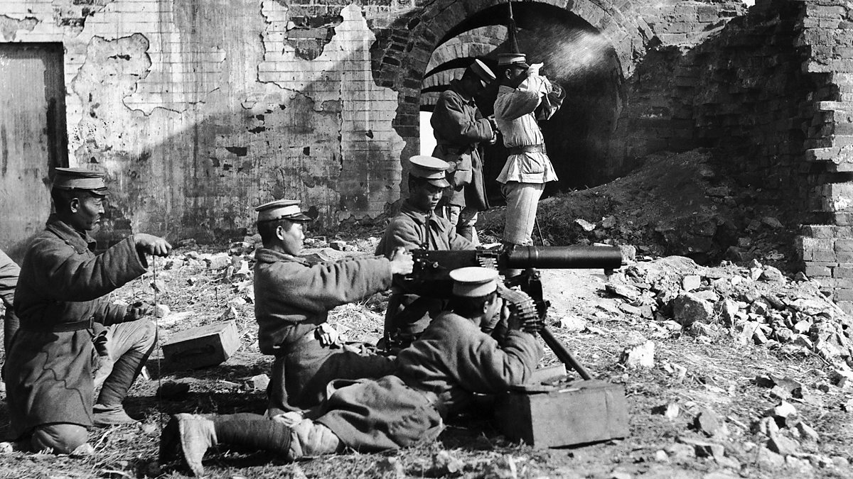Manchuria and to transfer the tracks to the Chinese gauge. Throughout, this period Chiang was focused on defeating the Communists from his southern powerbase. Japanese resistance was from a persistent guerrilla campaign by northern Chinese. The Japanese failed to realise that the Chinese they were facing, may have been underequipped but they were not the same Qing conscripts they easily defeated in the First Sino-Japanese war.
* Chiang’s strategic mistake was his attempt to broker a deal with the Soviets in 1936 at Xian, which resulted in his generals mutinying and temporarily taking him hostage. With Japan and Germany signing the anti-Comintern pact in 1936, Stalin now feared encirclement by his two principle adversaries and reached out to the Nationalists who he viewed as a more credible opposition to Japan than the Chinese Communists. Chiang was caught, in that he needed military equipment, but all the western powers were offering were empty words. However, the support that the Soviet Union could offer would be unlikely to be decisive against Japan yet dented his credibility. In hindsight, given the Japanese economic position, Chiang should have realized that Communism presented the biggest threat to his regime. The Soviet Union were able to assist in the spread of Communism in Northern China, but did not follow up on their promise to assist militarily when war broke out between China and Japan in 1937.
* On 7 July 1937, a Japanese company lost track of a single soldier during night manoeuvres near the Marco Polo Bridge on the southwestern outskirts of Beijing. To find him, the Japanese demanded to search the position of China’s 29th Army. The Chinese refused. Someone fired and then both sides fired. The Japanese called in reinforcements and remained on the attack. Meanwhile, the missing soldier turned up unharmed. No matter. The Japanese demanded that the Chinese withdraw the garrison. They began to do so, but slowly, so the Japanese bombarded it on 9 July. The Japanese had not wished to carry out a full-scale invasion of China at this point, they were more worried about protecting their Manchurian gains from a potential Soviet invasion. However, they had miscalculated Unlike past altercations, the Chinese did not choose to back down. The Nationalists honored the deal brokered at Xian to fight Japan under a Communist– Nationalist alliance armed by Russia. Japan again appeared in the League of Nations, to bring forward the allegations that Japan had broken international law in its use of poison gas and non-military aerial bombing. The League offered moral condemnation but nothing else. With no economic sanctions against Italy over Abyssinia this was always unlikely. Britain had been exploring improving relations with Japan in order to gain access to Manchukuo – they had only pulled back for fear of damaging relations with the USA and potential conflict with the Soviet Union.

For what reasons did the League fail in Manchuria?

What will be the significance of this failure?

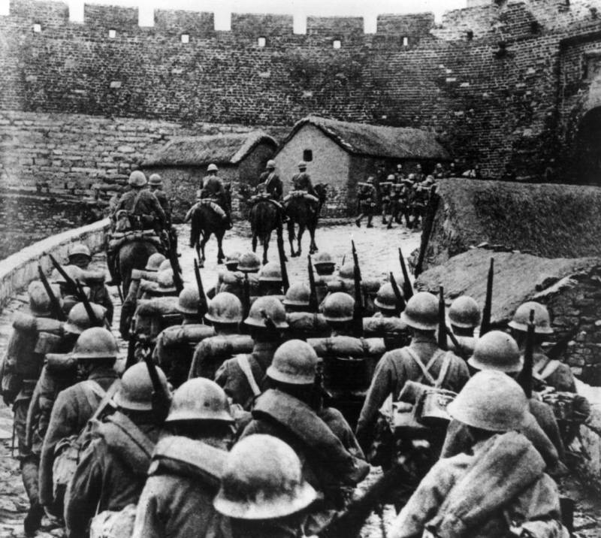Why could Japan not defeat China?

**Rearrange from the Most Important to the Least Important**

Japan’s nationalism meant that it could not adapt its strategy to make the changes needed to defeat a country the size of China. China had been conquered by outsiders before, but only with the assistance of disaffected Han Chinese. When the Manchu had invaded in the 17th Century, they had found that they were unable to occupy effectively beyond Hebei and Shandong and they relied on former Ming generals to pacify the Yangtse and the South. While the nature of this conquest caused lasting resentments and further wars to bring these generals under control it nevertheless allowed the Qing Dynasty to rule unopposed for over 250 years and the Qing correctly understood that if they let Han nationalism develop then it would undermine their ability to rule. The Japanese were also invading a China that was far more divided than it had been in the Ming Dynasty and there were ample opportunities for corroboration, especially as clashes between Communist and Nationalist forces continued during the invasion.

As we have seen, Nationalist education material had already stirred up anti-Japanese sentiment, but the actions of the Japanese only increased this. The burning of the undefended Zhejiang and then the Rape of Nanjing in 1937, was so extreme and barbaric that it meant that the Chinese would suffer far greater privations in order to defeat Japan than it would have been thought possible to achieve. On a local level, the Japanese policy of having their soldiers live off the land, turned the population further against Japan and was insufficient to feed the army. The number of opponents meant that Japan tried to economise. They equipped units with biological and chemical weapons and used them throughout China. They tried to spread anthrax, the plague, typhoid, and cholera, sickening their own and the enemy alike. Although, Japan eventually saw the military folly in their decision, they had outraged both Chinese and Western public opinion.

Russia also provided large amounts of support from 1937-1941. Russian military equipment began arriving in September 1937. From 1937 to 1941 Russia sent 1,235 planes, 1,600 artillery pieces, 50,000 rifles, over 14,000 machine guns, over 300 advisers, over 2,000 pilots, over 3,000 engineers and technical experts, and thousands of drivers to deliver the goods. Russian pilots flew from Nanjing, Wuhan, Chongqing, Chengdu, Lanzhou, Xi’an, and other places and over 200 Russian pilots died in China. In July 1938, Japan was forced to call off the Wuhan campaign due to escalating border conflicts with Russia, near Vladivostok. The Japanese were defeated and forced to sign a ceasefire, giving up Manchurian territory – the 200,000 Koreans who farmed in this area were deported to Kazakhstan. After 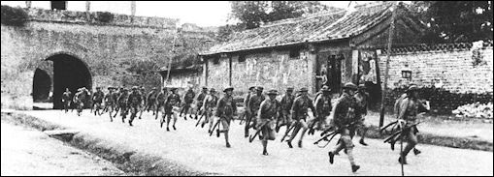the fall of Wuhan, the Russians again put pressure on the Japanese in attacking them at Nomonhan in Mongolia. Although the figures are disputed, it is likely that Japan lost 80% of the frontline soldiers as well as most of their tanks and 220 aircraft.

The Chinese generalship began to learn from their earlier mistakes. Chiang had attempted to forestall the Japanese advances in Central China, by opening up a second front in Shanghai in August 1937, this would be one of the largest battles of the war with 700,000 Chinese deployed against 300,000 Japanese. Despite a lack of firepower, the resistance of the Chinese surprised the Japanese and heartened Chiang, who believed that resistance would be possibly providing he could secure the necessary equipment. Although the Nationalists suffered 260,000 casualties, the majority occurred in the botched retreat, a tactical mistake that Chiang recognized and learnt from. The 60,000 Japanese casualties were of greater concern, as they were simply unsustainable. The following year when Wuhan fell, Chiang had already planned for an orderly retreat with the majority of the cities industry moved to Sichuan. By 1939, although hard pressed, the Japanese had run out of accessible targets and the Nationalists were able to achieve some isolated successes such as the Battle of Kunlun Pass to keep the route to Vietnam open and in the Battle of Changsha.

Chiang could also be ruthless in order to prevent defeat. In June 1938 in order to prevent the movement of the Japanese inland he ordered the breaching of the dikes at the Yellow River, which inundated 70,000 km2 of agricultural land, killing 900,000 and causing 3.9 million to become refugees.

By the Spring of 1940, the Communist forces were sufficient to wage a conventional campaign against Japan. The hundred regiments campaign was a disaster and the population in Communist controlled areas declined from 44 to 25 million, it nevertheless opened up another front on an already overstretched enemy. It also forced a tactical retreat from the Nationalist forces, which inadvertently lifted the blockade of Communist held areas. This was problematic for Japan, who viewed the Communists as the greater long-term threat.

Despite numerous Japanese offensives, after 1938 they failed to hold the new territory. As soon as their main units departed for battles elsewhere, Chinese forces returned. In the second half of 1937, Japanese forces had advanced 17.4 kilometers per day; this declined to 7.6 kilometers per day in 1938, to 1.1 kilometers in 1939, to 0.6 kilometers in 1940. The Second Sino- Japanese War had stalemated. China was too large a theatre to be garrisoned in the absence of any Chinese co-operation. The Military government had failed to realise what their forbears did, that Japan only had the ability to fight short decisive wars.

Japan also believed that if they knocked out China’s ‘centre of gravity’ then the country would collapse. Despite taking the capitals of Beijing, then Nanjing and Wuhan the Nationalists moved their capital again to Chongqing, far removed from the Japanese railheads. The 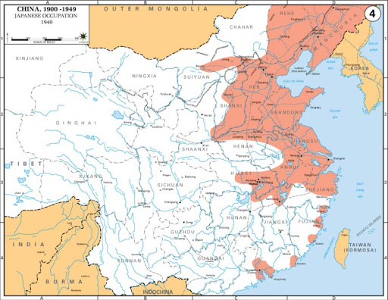move inland meant that China lost 87% of its prewar production, which still only recovered to 41% by 1945. China had also lost 90% of its prewar tax revenues and 95 million Chinese had become homeless. But despite these problems, the poverty of China was proving to also be its advantage as the cost of maintaining the areas it conquered was far greater than any economic worth they could provide for Japan.

The Chinese instituted a fairly successful guerilla campaign, with 600,000 to 700,000 Guerilla forces operating behind enemy lines, as well as warlord forces in the North. The combination of guerrilla and conventional forces proved lethal. The new strategy impeded the Japanese ability to launch major new offensives. Japan’s conventional army needed to concentrate to fight Nationalist armies but to disperse to fight the insurgency. Yet it could not do both simultaneously. When Japanese troops dispersed, Nationalist main forces concentrated to eliminate these isolated elements. The insurgency undermined security in Japan’s rear, blurred the front lines as the boundary between hostile and safe territory, and stymied economic development in Japanese- occupied China, the rationale for the invasion. As the Japanese pushed ever further from the sea and strayed from China’s limited railway network, they extended their logistical lines and expanded the territory to garrison. While the Chinese could not defeat Japan, they could deny Japan victory. Their prevent- defeat strategy, which regardless of their losses still allowed them to fight another day, negated the Japanese strategy for a quick decisive victory. The insurgency forced Japan into a point– line strategy of defending cities and the railway lines connecting them. But this left the countryside to the guerrillas and to the Communists, who remained to organize the peasantry with promises of land ownership. Japan simply lacked the forces to garrison China’s vastness. Chiang Kai- shek believed that Japan would eventually choke on its conquests, when overextension and exhaustion would force it to withdraw.

What had begun as a limited war, soon became one with an unlimited objective. This raised the economic conundrum of sunk costs. As Japan, put more resources into the war it would therefore require greater demands from China in order to justify the initial expense. By 1939, Japan had occupied one third of China and had a presence in 21 of the 29 provinces. Yet despite taking 92% of Chinese industry and 40% of the agricultural land, this was not enough of a gain to begin peace negotiations. The lack of production in China, meant that the Japanese industry was having to move to heavy production, with 73% devoted to this by the end of 1941. This resulted in living standards in Japan to decrease by 20% and meant that Japan was not only reliant on imports of raw materials, but also for consumer goods, which inflation was making ever more difficult to afford. The end result was that Japan was running out of troops and material to conduct this endless war in China.