League of Nations Dispute 1920

**Vilna**

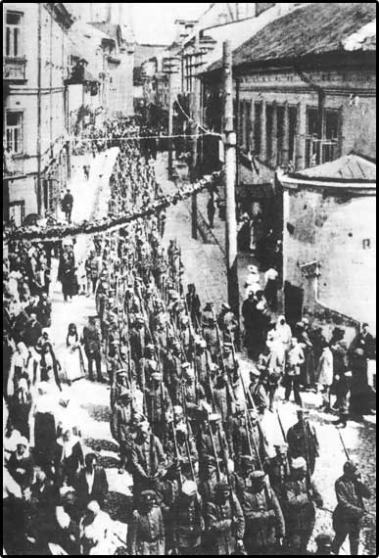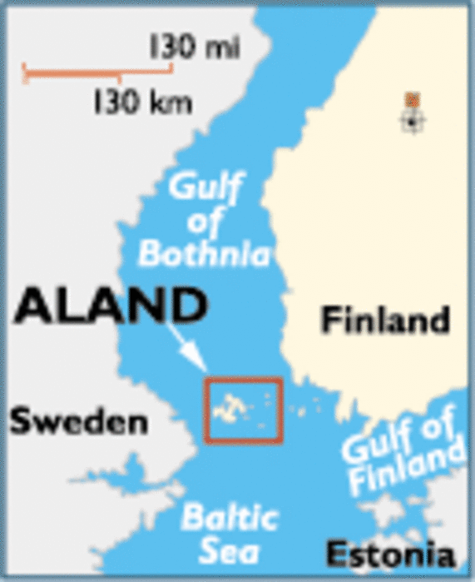

**Disputers**

Poland and Lithuania

Population

195,000

(30% Polish, 2% Lithuanian)

History

  Was the Ancient capital of Lithuania when it existed in the Medieval period.

  It had been part of the Russian Empire since 1795.

⬥ German Troops occupied it from 1915-1918

⬥ In February 1918, Lithuania declared itself an independent state with Vilnus as its capital.

⬥ It was captured by forces from the Soviet Union in 1919, but they were forced out of the city in July 1920. Before they left they ceded the city to Lithuania.

⬥ In September 1920, Vilna is found to be Lithuanian by the League.

  In October 1920, Polish Forces capture and occupy the city and refuse to leave. The city is renamed Wilno.

