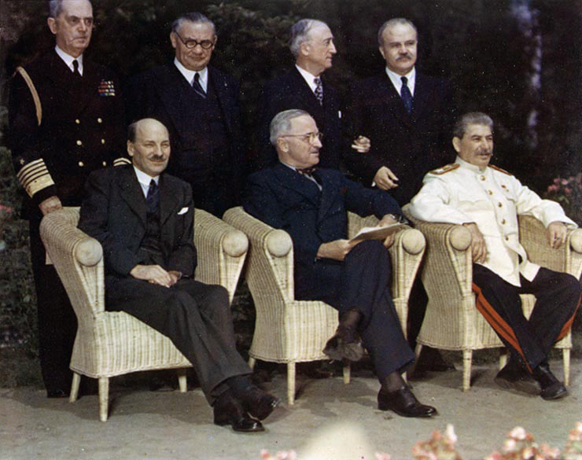POTSDAM SUMMARY

What had changed?

1. De-Nazification protocols were put in place for the occupation zones and the procedures for the trials of Nazi war criminals.
2. The Polish Provisional Government was formally recognized. Provisions were made to move the 5 million Germans remaining in Poland to the Western zones of occupation.
3. The Soviets were informed that they would take their reparations out of their own zone of occupation only aside from 10% from Western zones. Poland would get reparations from the Soviet sphere.

What was the same?

1. The zones of occupation remained.
2. Free elections were still ‘planned’ for Poland.
3. Soviets remained in the Baltic and Eastern European Countries

Why do we care?

1. It was an extremely fractious conference, very little movement was made on key issues. Especially the future of Germany and the arrest of the Polish government caused a heated argument.
2. No other concessions were made.
3. There would be no more multilateral meetings for the remainder of the Cold War. It would be the last time that Truman and Stalin spoke.

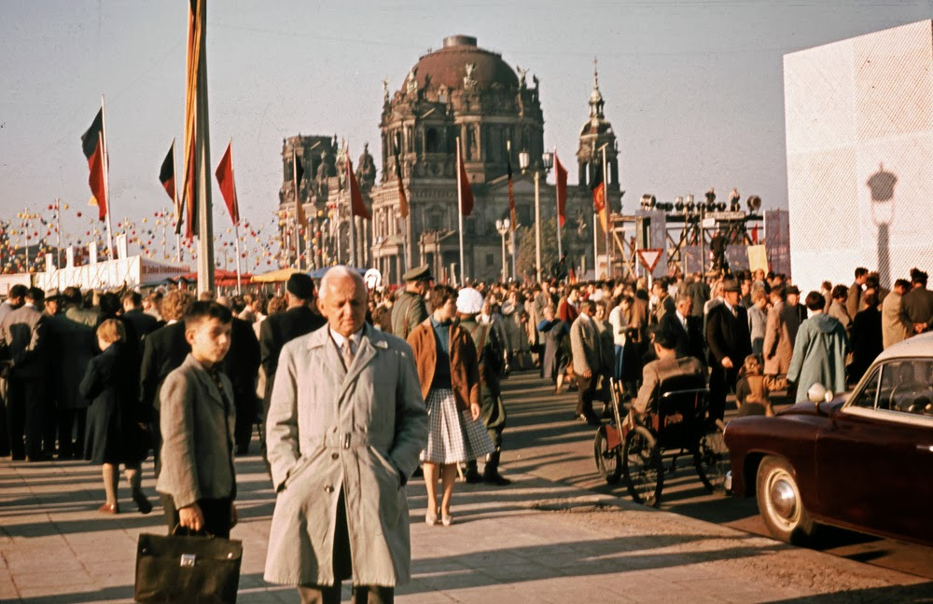In Summary

Churchill and Roosevelt felt there had been a spirit of co-operation at Yalta whereby future disagreements were to be solved through discussions in the UN.

Stalin believed that Soviet security rested on the creation of compliant satellite states on his Eastern borders.

Churchill felt as though he had been betrayed and even Roosevelt was coming to that opinion before he died. The only direct violation was the arrest of the Polish government, but the vagaries of the language of Yalta meant the most they could accuse Stalin of was going against the spirit of the agreement.

President Truman had run out of patience with Stalin and his actions in Eastern Europe. Churchill was happy to let Truman lead as his ideas matched his own; Atlee who replaced Churchill, also stood behind Truman.

The Atomic Bomb, meant Truman no longer needed Soviet help and could genuinely protect Western Europe. Non-Communist powers who felt threatened by the Soviet Union increasingly looked to the US for protection.

What changes to the frontiers of Poland were agreed at the Potsdam Conference?

What was decided at the Potsdam Conference?