______________________________Picking an EE Research Question_________________________

This is supposed to be an enjoyable activity. It is therefore vitally important that you choose something that you want to study and will enjoy doing. It should take around 40 hours and be 4,000 words. There can be no overlap with anything done in class or an IA.

Process

1. You need to do two Potential Research Question forms for two different subjects and have them up on Managebac by 10 December clearly label what is your first and second choice. IF YOUR FIRST CHOICE IS IN THE GREEN COLUMN BELOW, YOU ONLY NEED TO GIVE ME ONE PROPOSAL AS I CAN GUARANTEE A TRAINED SUPERVISOR.
2. You need to follow the steps to making a good proposal carefully.
3. I am going to read through all the proposals to ensure that everyone has a specialized subject supervisor. It is my aim that everyone has their first choice. If some areas are too popular then I will read through the second choices and have a conversation with you about moving subjects. If you have a viable proposal I will not change your subject.
4. YOU ARE NOT TO SELECT TWO SUBJECTS THAT ARE IN THE PINK COLUMN BELOW.

|  |  |  |
| --- | --- | --- |
| Subjects which were under subscribed last year | Subjects that were about right last year. | Subjects which were over subscribed. |
| English Language A  English Language B  Chinese Language A  Mathematics  History  Geography  Lit and Performance  World Studies  Global Politics | Sports Science  Psychology  Computer Science  Theatre  Music  Film  Business Studies  Chemistry  Economics  Visual Arts | Biology  Philosophy  Psychology  Physics |

Statistics

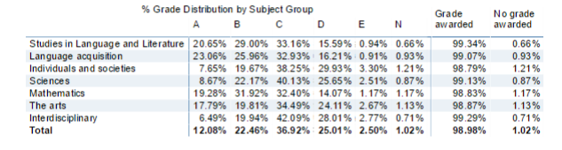

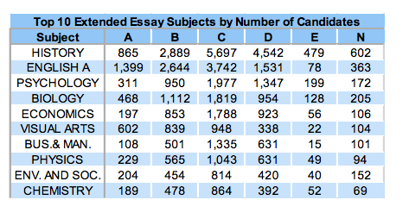

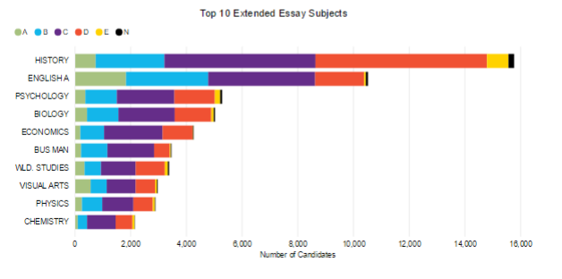

Lessons to take from the statistics:

1.

2.

3.

4.

5.

|  |  |
| --- | --- |
| Group One  Chinese  - This is for those who have an interest in Chinese literature. You are not to select it just because you feel it is easier to write in Chinese.  English  - You can compare a piece of English literature with Chinese (or any other) literature, but you must use the translated version. The same applies to those comparing Chinese to English. | Group Three  Geography  - Requires the use of primary data. This should be conducted in the Songjiang/Shanghai area to get the best mark.  - You must be able to show your findings on a map  - Work completed on a school field trip will not count.  History  - This is the most commonly selected subject in the world.  - You do not need to study History to do a an essay in this subject.  - Events cannot be discussed that occurred in the last ten years.  - Primary and Secondary data will get the best grade.  Economics  - Areas of Investigation have to be within the last five years (future or hypothetical events do not count).  - Make sure you can absolutely access raw data if you want to select this as a topic.  - Questions about market structures must be checked with your teacher  - You cannot study an entire countries economy as a topic  Business Studies  - You should focus on business management theories or principles learned in class and their application in the real world.  - You should not focus on one particular business (e.g. your parents) or use one source only (e.g. an annual report.)  - It should be forward looking not a recap of what happened. You use past examples and apply your theoretical knowledge to make predictions.  Global Politics  - This is not a taught subject at YK Pao School. As a result you will need to have an interest in global politics and already be aware of some of the key ideas.  - These can only deal with events that occurred in your lifetime (background is accepted).  - It should involve more than one country (I would highly recommend not touching HK or China)  Philosophy  Philosophy should focus on:   * an idea from one philosopher rather than several * a single text by a philosopher rather than the whole of his or her work. * Non-philosophical sources should not be used. * You should envisage counterclaims or objections, address them and, if possible, rebut them. * Also explore the wider implications of the issues they raise without becoming irrelevant. * You can take an independent position but it should be supported by evidence.   Psychology  - Make sure you have a genuine interest in Psychology before you select this if you are not taking the course.  - Pop-Psychology is not acceptable as a topic.  - Anything on dysfunctions or psychiatric disorders must be chosen very carefully.  - No primary data collection is allowed for psychology. |
| Group Four  Biology  - Be careful there is no cross over with any other sciences.  - No tests on animals which can cause pain.  - No experiments on humans or accessing confidential medical records.  - All experiments must be carried out on school property under the supervision of a Science teacher.  Chemistry  - It is not meant to be a research into conflicting theories.  - No use of dangerous materials.  - All experiments must be carried out on school property under the supervision of a Science teacher.  Computer Science  - This must contain personal experiments and should display a high degree of technical knowledge.  - You can create data from your own programs but may not get credit for designing the program. This is not a programing activity.  - You can look into the future but this should not be a history of computing.  Physics  - Avoid broad or complex topics that are outside the IB curriculum.  - Constructing your own equipment will be of no benefit. You should use the school’s equipment and all experiments must be supervised at school.  Sports Science  - These should focus on human performance, exercise or nutrition.  - No experiments which will cause pain or discomfort or use bodily fluids.  -Primary Data should be used on conjunction with secondary data. | Group Five  Mathematics  - This is not a common topic even though it has a high percentage of A’s given.  - You can choose from any area you like (e.g. engineering) as long as the focus is mathematical uses within this area.  - A history of mathematics is also acceptable. |
| Group Six  Visual Arts  - You must choose art works that you have access to view or have done so in the past.  - Must combine art theory with personal critical analysis.  - Personal contact with artists is encouraged.  Music  - You cannot investigate musical history, development, human effects or lyrics.  - You must choose a piece of music with which you have a personal connection.  - The marker does not have to listen to any of your pieces of music.  Theatre  - Can be theoretical only but not recommended  - Practical applications can be audiovisual  - No visual material can be submitted with the essay  - A literary approach should be a Literature and Performance essay | Interdisciplinary  World Studies  - I have talked to many of you about approaching this.  - Must show how something in a local environment illustrates something of global importance.  - Must include two IB subjects in these areas:   * Conflict, peace and security * Culture, language and identity * Environmental and/or economic sustainability * Equality and inequality * Health and development * Science, technology and society   Literature and Performance  - You must have studied IGCSE drama  - You must have access to any piece of literature’s live adaptation on DVD or be able to see it in person.  - Movies do not count as performance.  ESS   * This should focus on the human interaction with the environment. * They can be descriptive so be sure to have a clear evaluative focus. * Something that you can visit would be ideal. China offers numerous case studies. * Primary research is allowed but inadvisable. |