_________________________History IA: Instruction Sheet__________________________

Timeline

21 December: Introduction to the project.

5 January: Topic required to be emailed to your teacher. Questions will be confirmed on a case-by-case basis.

18 January: Should have had a 20-minute meeting with your teacher to finalise a question and discuss potential sources. If you want to wait until after CNY then that is fine.

21 April: The draft for Section Two is complete (this gives you ten weeks after Chinese New Year). This will be a summative assessment.

12 May: Between 23 April and 14 May you will write a Paper 2/3 essay as a summative assessment.

16 June: Draft of Section One and Section Three is due. This will give you two weeks for Section One and one week for Section Two.

19 September 2023 Project is complete. Those that are in on time will be the last chance to move your Predicted Grade (we don’t take them down)

* I am not going to tell you what to choose as a topic. I think there is more than enough interesting topics from within the course, you have plenty of valid questions and all the sources you could want, but if you really feel you need to do something else, then I can’t stop you. The average score when students could pick their question from any era was 19.2 for questions on the course and 17.3 for those that were not.
* Questions must be specific as they can possibly be. You are taking a small incident that potentially illustrates an important idea. This is not the time to be taking on major issues.
* Nothing from within the last 10 years should be mentioned at all.
* The 2200 words is a hard number. I will stop reading at 2200 words as this is what the IB examiner will do when they are moderating my marking.
* Local Social History is being encouraged and is more likely to get a higher grade. You will be able to tap into unique Chinese sources and will be able to tap into oral history sources. If you are not doing anything on our course I would encourage you to do is something about your personal family history or something about the history of Shanghai where you can actually visit sites and museums to gather sources. The problem with this is that it is hard to get perspectives into your work.
* The vast majority are on the 20th Century and in particular Authoritarianism and the Cold War. If you are going to go into these areas, then you need a really unique question.
* It cannot be the same as your EE. I highly recommend choosing a completely different topic.
* Your actual content is only going to be 1300 words, which is not very long at all.
* The quality of writing will contribute to your grade. You are not good at writing!

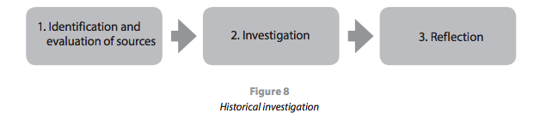

Part One: Identification – 500 words

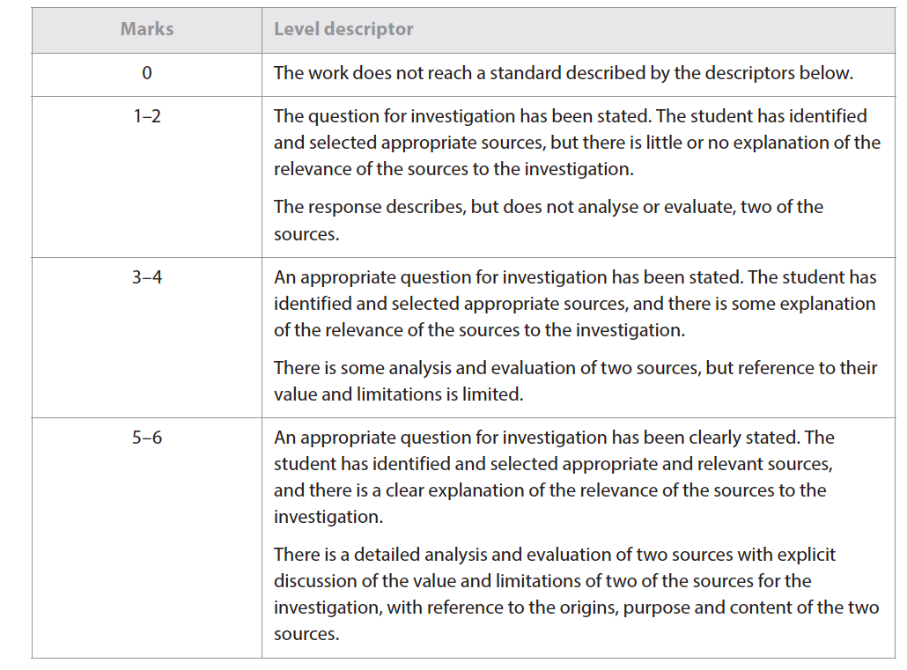

* You should try and find two sources that are vastly different. i.e.

Primary vs Secondary

Marxist vs Establishment

Feminist vs Patriarchal

Modern vs 19th Century

Western vs Eastern

Orthodox vs Revisionist

Print vs Audiovisual

* You have to explain the reason you chose these two sources. You are not trying to find the most reliable sources you are trying to find sources that are offering differing perspectives.
* Weaker students will choose sources like a text-book or wikipedia

You should set it out like this:

**Question: 100 Words**

• Clearly state the question you have chosen to investigate (“This study will investigate the question…”)

• Include a brief explanation of the nature of the two sources you have selected for detailed analysis, including an explanation of their relevance to the investigation (“The first source I have selected for detailed analysis is…[describe *what* it is, *who* produced it, *when*, *where* and *why*]” / “This source is particularly relevant to the investigation because… [explain]”)

**Analysis: 400 Words (i.e. 200 words per source)**

Analyse the value and limitations of the two sources in relation to the investigation, with reference to their origins, purpose and content (“The origin of this source is…from this we can deduce its purpose is…On this basis it is valuable for an investigation of the key question because [*focus on what it says/implies, why we should trust it*]…Nevertheless the source does have some limitations for this particular investigation because…[*focus on what it leaves out, why it might not be totally reliable*]”). If you are going to criticise the source, then you need academic justification or evidence of unreliability you personally find. Reading reviews online is not acceptable. Keep the focus firmly on the source in particular not just general rules for sources of this type. Also keep the focus clearly on your research. You need to make a total of 12 points. I would treat each source origin, purpose and then content. Give the strength and then the limitation.

The key is to avoid speculative statements. This is statements like:

As a Spanish historian, he might be supportive of Cortes; Or,

As this is from the 1920’s it could be missing key archaeological evidence.

You are the person who has read the source and thus you should be able to identify the strengths and limitations of the source in answering your question.

Just because a source is a primary or secondary source has no intrinsic bearing on its usefulness. Avoid formulaic comments.

Part Two Investigation – 1300 words

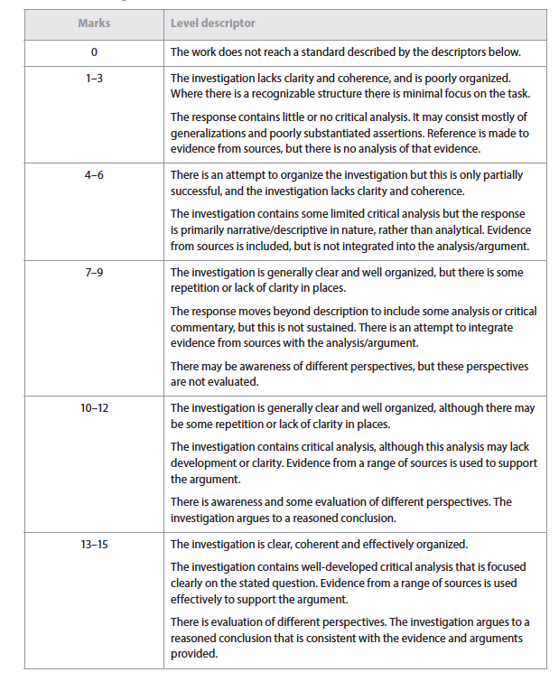

You only have 1300 words, do not waste time explaining background or events. It needs to be argument based.

You should present more than one argument, and it should be clear.

Arguments must be explained from multiple perspectives. You are not going to make the top mark band without evaluating the different perspectives to find which is the most valid. Where possible tie the historian to the particular school or time period that they represent. You only have to demonstrate this.

Narrative style or irrelevant material will kill your grade.

You must have a conclusion that answers your question; two or three sentences is fine. Better to have a clear point

You should set it out like this:

**Introduction (c. 100-150 words)**

• Set the scene / generate reader interest by establishing why this question was important at the time, and remains relevant today.

• Summarise the different historical perspectives that exist in relation to the question.

• Outline how the essay will be structured, and the main conclusions that will be reached.

**Main Body (c. 1000-1100 words)**

Evaluate the evidence for several different perspectives in separate paragraphs. Within each paragraph, start with a clear topic sentence which is clearly focused on the question. Then explain it with carefully selected and properly referenced evidence (use quotes as necessary). Ensure that you stress the value of the evidence you use, but also acknowledge its limitations, with reference to Origin, Purpose and Content as appropriate (Don’t over do this). I would aim for four paragraphs along with your introduction and conclusion

**Conclusion (c. 100-150 words)**

Provide a direct answer to the question you set yourself by synthesizing the main points of the essay. In particular, stress which historical perspective you agree with most and why, and which historical perspective you reject and why, or whether you think it is possible to accept different elements of different perspectives to provide a new interpretation.

So, for the essay I set:

**'How influential was native intelligence in the decision of Hernan Cortes to massacre the Cholulans in 1519?'**

I would structure it like this

Introduction – The Cholulans as a microcosm of a wider problem? i.e. the dangers of taking the Spanish word for what happened and also the dangers of downplaying Mesoamerican involvement in the decline of the Aztec.

Part One: Tlaxcalan and Cempoalan involvement. The evidence for that involvement and then evidence that this is fabricated.

Part Two: Malinche. Who alleges that she contributed and then why could we greet this with suspicion.

Part Three: Cortes needed to assert dominance and the arguments against

Part Four: It was a collective Spanish, decision and the arguments against.

Conclusion – Revisionists have perhaps overstepped that it represented an overreaction of the Spanish born of an innate understanding of their own fragility,

**Citations:**

The citations and bibliography section on the History guide for the EE will give you all the information you need on how to cite properly.

Part Three: Reflections - 400 words

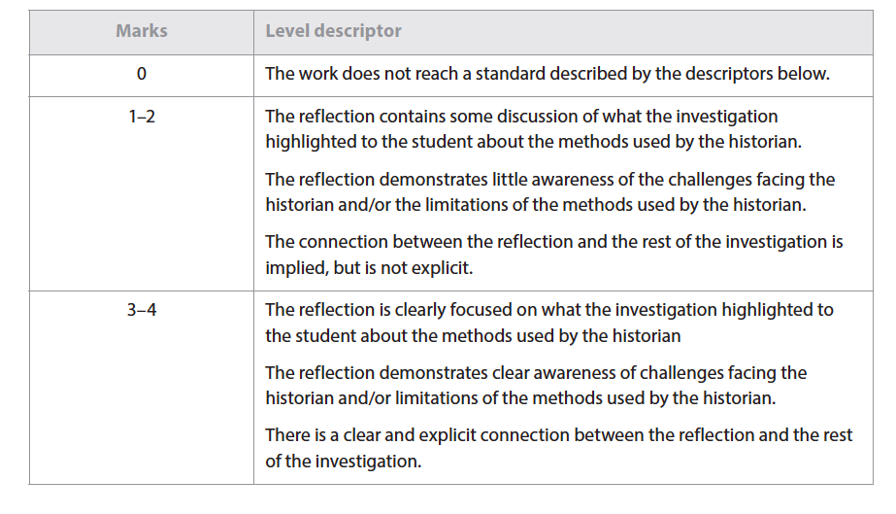

This section of the internal assessment task requires you to reflect on what undertaking their investigation highlighted about the methods used by, and the challenges facing, the historian. It must be balanced between describing the general challenges and ideas and the evidence of this in your own research.

You can’t talk about general problems that historians face. It is the methods you used and the challenges you faced as a historian. At the same time it is not like an EE reflection. You need to talk about the problems/issues of historians and how this was evident throughout your research.

Examples of discussion questions that may help to encourage reflection include the following. It must be tied to your research with examples, not just History in general.

• What is the role of the historian?

• Should historians aim to inform, or to persuade?

• What methods used by historians did you use in your investigation?

• What did your investigation highlight to you about the limitations of those methods?

• What are the challenges facing the historian? How do they differ from the challenges facing a scientist or a mathematician?

• What challenges in particular does archive-based history present?

• How can the reliability of sources be evaluated?

• What is the difference between bias and selection?

• What constitutes a historical event?

• Who decides which events are historically significant?

• Is it possible to describe historical events in an unbiased way?

• What is the role of the historian?

• Should terms such as “atrocity” be used when writing about history, or should value judgments be avoided?

• If it is difficult to establish proof in history, does that mean that all versions are equally acceptable?

Given the word limit there is only space to evaluate two ideas or challenges.

Bibliography

This must be here, but is not counted in the word count.

This is a real case of selection of sources. Once you get over eight sources you are probably having too many. You need to look for good quality sources that offer differing perspectives.

Again, go to the History guide to see how to lay it out.