**What did the Big Three Want Out of The Peace Settlement?**

**They Agreed…. __________________________________________________________________________________________________________________________________________________________**

Ch. 1

p.83

17-19

6-7

8

BRITAIN__________________________________Main Aim

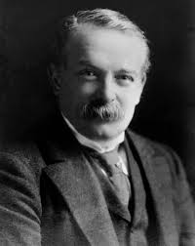

Reparations Army______

German French Border Poland____

War Guilt Colonies___

Ch. 1

p.82

20-23

3-4

8-9

FRANCE__________________________________Main Aim

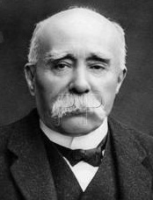

Reparations Army______

German French Border Poland____

War Guilt Colonies___

Ch. 1

p.82-83

14-16

4-5

6-7

WHAT ABOUT GERMANY?

USA_____________________________________Main Aim

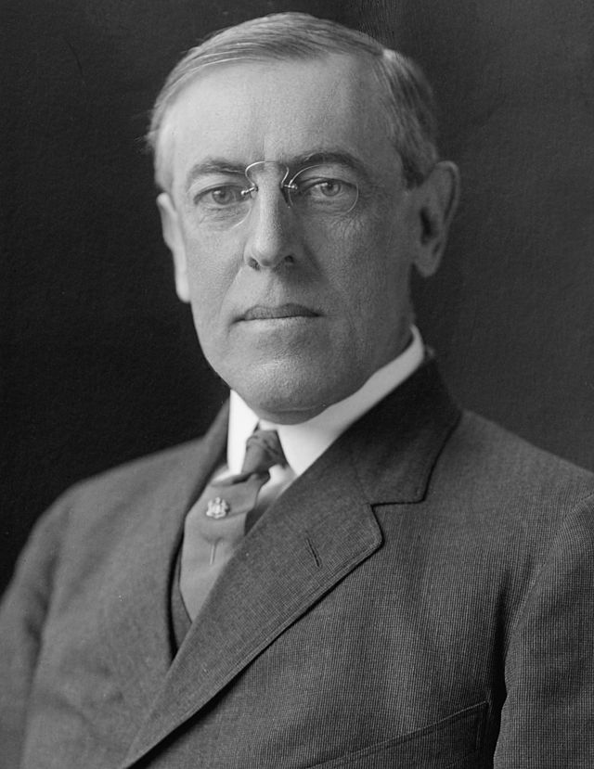

Reparations Army______

German French Border Poland____

War Guilt Colonies___