**League of Nations Revision**

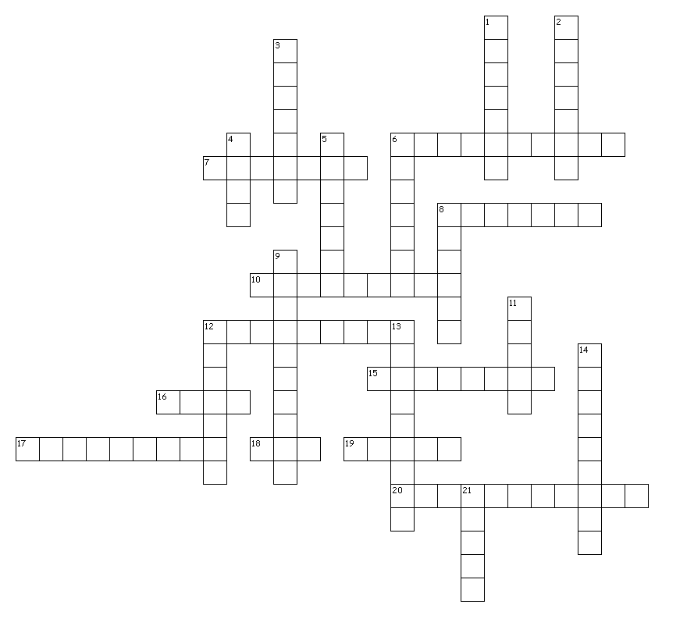

Across

6. Election to decide ownership of a particular area

7. City at the centre of a dispute between Czechoslovakia and Poland

8. Country that received the Aland Islands

10. Biggest city in the Aland Islands

12. Country that the League decided owned Vilnus in 1920

15. What all members of the League were supposed to abide by

16. Terrorist organisation in Greece and Bulgaria

17. What decisions in the League of nations had to be

18. Animal that may have started the Greek-Bulgarian War

19. City where the International Justice Court met.

20. In charge of note taking for the League

Down

1. Country who the League of Nations stabilized their economy

2. Country that supported Germany during the Upper Silesia crisis

3. Area of Bulgaria where Greece invaded

4. Removed from paint by the League

5. Murdered Italian which triggered the Corfu crisis

6. Part of Germany where Memel used to be

8. Country that was supposed to supervise Memel

9. City where a treaty on Naval Disarmament was signed

11. Polish name for Vilnus

12. Disease almost cured by the League of Nations

13. What the Greeks refuse to do during the Corfu crisis

14. Leader of Italy who invaded Corfu

21. Part of Upper Silesia eventually given to Germany