**Why Did the USA Not Joint the League of Nations in 1919?**

1. Opponents

**Republicans**

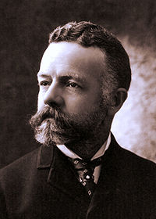

*Henry Cabot Lodge*

**Reason for Opposition**

**•**

**•**

**•**

**•**

**•**

**•**

**Irreconcilables**

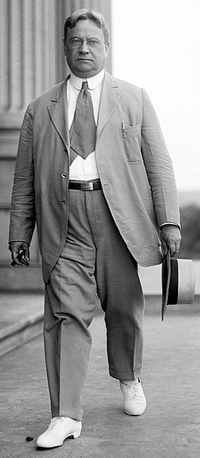

***Hiram Johnson***

**Reasons for Opposition**

**•**

**Actions taken by opponents**

**•**

**•**

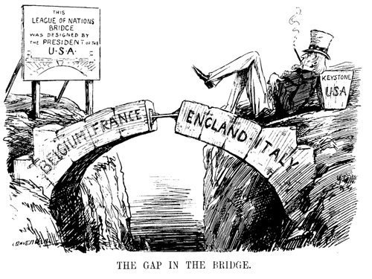

Explain with evidence what the main message of the cartoonist was.

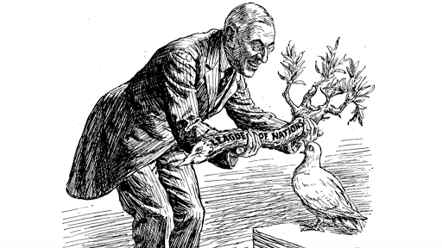

Explain with evidence what the main message of the cartoonist was.

**Actions taken by opponents**

**•**

**•**