**The Building of the Berlin Wall**

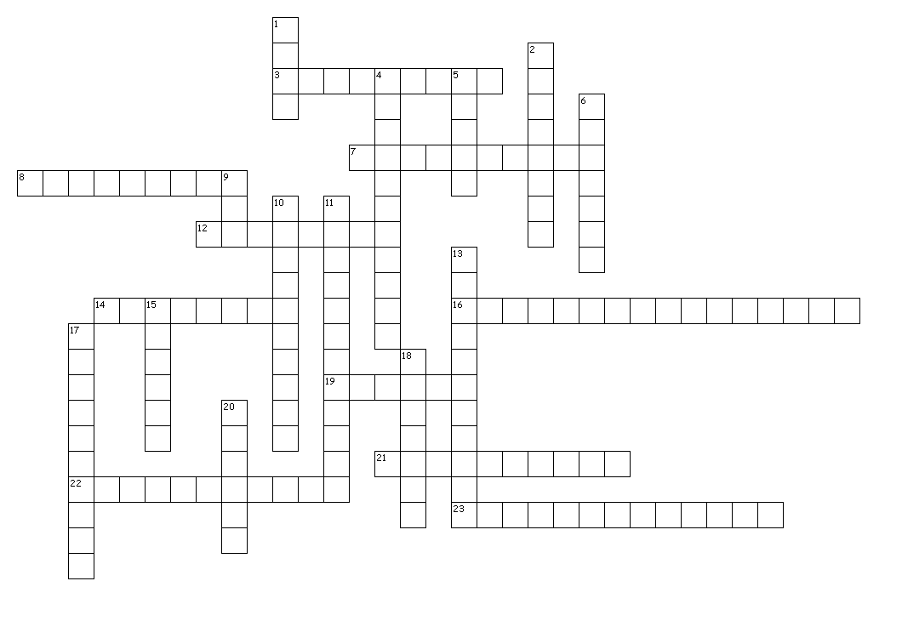**August 1961**

**Across**

3. Communist who favours heavy industrialisation and a cult of personality.

7. Subduing people with the threat of force

8. A final demand

12. Something that is unconventional and artistic

14. Leader of the GDR

16. Prison in East Germany used by the Secret Police

19. A type of hunting bird

21. Remove or loosen restrictions on the economy

22. Making your power over something stronger

23. Taking armed forces away from an area

**Down**

1. Catholic church service

2. When you are willing to take a number of options

4. Not taking instructions from anyone else

5. A type of sword

6. Leader of the USA when the wall was built

9. Leader of China

10. What a government feels that it needs to rule

11. Fall to pieces

13. Airport in East Berlin

15. Mayor of West Berlin

17. Leader of the Soviet Union

18. When you are full of confidence and aggressive

20. A church administrative area

Video Questions

1. How is the nuclear armament of Western Germany and the training of a West German army raising tensions?
2. What was so appealing about West Berlin?
3. What was Khrushchev threatening over West Berlin and how did Eisenhower react?
4. Why was no progress over West Berlin in 1958?
5. How did Khrushchev get what he wanted from the first Berlin crisis?
6. Did the reality of East Germany in 1959 match the propaganda videos?
7. Why were so many East German’s leaving and how were they able to do so?
8. What was the effect of this on East Germany?
9. Why did Khrushchev wait until after the departure of Eisenhower and the arrival of Kennedy to attempt to make another move on Berlin?
10. What are Dobrynin’s criticisms of Kennedy?
11. Why was Kennedy so worried about America’s options in dealing with the second Berlin ultimatum?
12. How was Kennedy’s July speech both tough and offering a way out of the crisis?
13. How did the people of East Germany react to the crisis?
14. Explain how the wall was prepared and constructed.
15. How were the Soviets careful not to create conflict with the USA?
16. What were the immediate effects on the people of Berlin?
17. How did the Western powers react and why?
18. How did the mayor of Berlin react?
19. What did Kennedy eventually do to show support to West Berlin?
20. How did people escape?
21. How did the East German’s present their building of the wall?
22. Why did a potential conflict nearly breakout at Checkpoint Charlie between the USA and USSR?
23. How and why was this situation resolved?
24. What was the significance of Kennedy’s visit to Berlin?

Long Term Causes

The leader of the GDR, Walter Ulbricht (a loyal and humorless Stalinist) had asked for a secure border to West Berlin since the creation of the Federal German Republic (West Germany) in 1952. There were orders to do so, which would have been carried out had Stalin not died in 1953.

Following the death of Stalin, leaders in the Kremlin urged Ulbricht to liberalise the economy and to raise living standards (which were actually worse than they had been in 1947); they hoped that this would encourage people to stay. The problem in East Germany was the same as those in the rest of the Eastern Bloc; that there was no clear vision for what post-Stalinism would be. Though they favoured more economic freedoms, the leaders in Moscow were not prepared to relinquish political control which resulted in a form of Stalinism-lite which did little to encourage East Germans that they were better off than they would be in the West.

In 1953, a wave of strikes was met with brutal repression in East Germany; this saw 400,000 flee to West Germany via Berlin. For the next eight years over 250,000 a year would leave the GDR. By 1961 3.1million had left since Ulbricht had taken over, which represented nearly 1/6 of its population.

Ulbricht used the uncertainty following the Hungarian Uprising to consolidate his own power. With Khrushchev unwilling to intervene in the Eastern Bloc again, Ulbricht used this opportunity to use his ultra-loyal deputy Hoenecker to remove any modernisers from the party and reinstitute Stalinist style economic planning. Now he was secure, he began to up the rhetoric he was using, in 1958 he went on the attack, claiming that West Berlin was part of GDR territory and promising that East Germany would be outperforming West Germany by 1961. He demanded that western leaders recognize the legitimacy of the GDR.

I often refer to the relationship between the Soviet Union and the GDR is that of the ‘Tail Wagging the Dog’? What do I mean by this and how can we see this in the relationship between Ulbright and the USSR in the 1950’s?

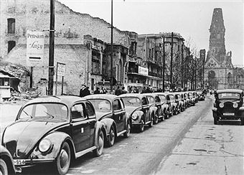

First Berlin Crisis

In 1958, Khrushchev was also in a bullish mood. In 1955 the Soviet Union had tested its first hydrogen bomb, in 1957 it launched the first unmanned satellite and now he had the missile systems ready to attack American cities. Khrushchev decided to start applying pressure where the West was most vulnerable—in Berlin. He would describe Berlin as ‘the testicles of the West. Every time I want to make the West scream, I squeeze on Berlin.’ On November 27, he gave a press conference where he delivered a six month ultimatum to NATO, to recognize the GDR and make Berlin a demilitarized free city or he would turn over all control of Berlin to the GDR. It was not a particularly well thought through plan (when asked what would happen when the ultimatum expired he told his son ‘then we will try something else. Something will always turn up)’, especially when Eisenhower responded by simply ignoring him. While Eisenhower, was non-plussed the British Prime Minister was panicked, on an official visit to Moscow, Macmillan promised a conference of ministers to settle the German question. The resulting conference achieved nothing, but the ultimatum was allowed to pass without incident. When pressed on the issue, Khrushchev asserted that he had been misunderstood. Khrushchev was pleased with the outcome; he had shown he was a worthy successor to Stalin by standing up to the West and received an invite to the US as a result. Ulbricht was less than happy, the flood of migrants through West Berlin was showing no sign of slowing.

How is Eisenhower handling the crisis well?

How is the First Berlin Crisis going to please everyone apart from Ulbricht?

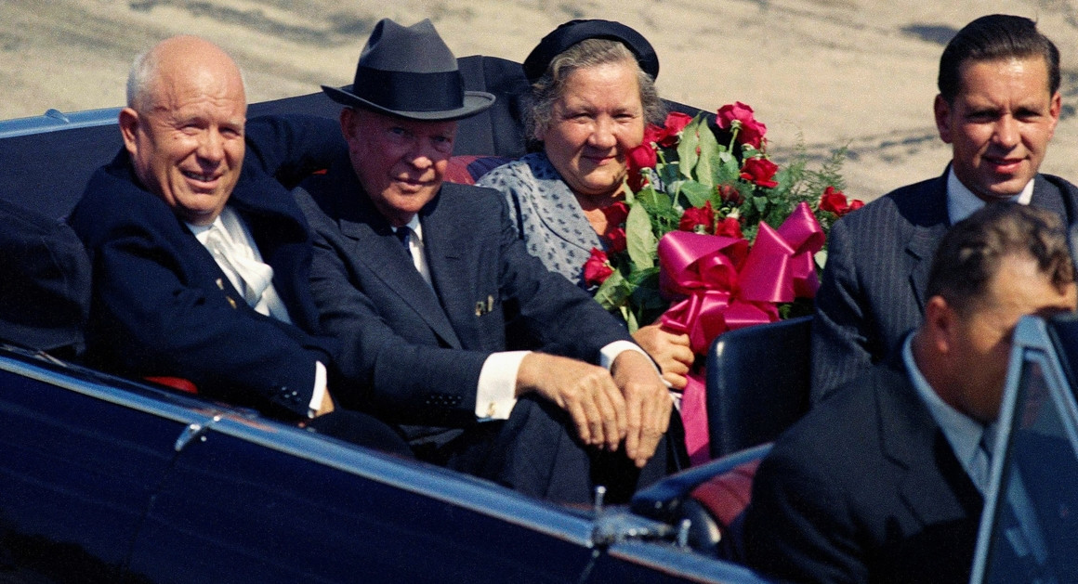

The Vienna Conference

In 1960, Kennedy came into power and immediately Khrushchev realized this may be his chance to make meaningful progress in Berlin. He perceived Kennedy as being pampered and weak, a man who could be easily cowed. Kennedy had done few favours for himself by promising a flexible response to the Cold War, signaling that he may be forced to negotiate (unlike Eisenhower who managed to create an impressively crafted version of a man who was completely indifferent to nuclear war).

In 1961, officials from the GDR made their first trip to China. This worried Khrushchev as he and Mao despised each other, mainly due to Mao’s insistence that Khrushchev should stop bragging about Soviet technology and actually use it to spread revolution and overthrow capitalism. In 1960, the Soviet Union had pulled its advisors out of China and scrapped all joint projects; for Ulbricht to visit China so soon without consulting Moscow was showing too much independence. In September 1960, Ulbricht forced all westerners to show ID before entering East Berlin; this caused a diplomatic incident. Once again Moscow was not informed. Khrushchev needed to show his support for the GDR, if it pursued too independent foreign policy then it may get itself involved in a war in which the Soviet Union would be bound to assist it. Khrushchev told Ulbricht to stay calm until he had a chance to discuss the matter with the new President, but Ulbricht ignored him, ratcheting up the border checks and accusing the West of spying and the kidnapping of East German citizens.

By the time Khrushchev met Kennedy in June 1961, he was fast running out of options. It was clear that if the situation in Berlin continued that the GDR would disintegrate and probably be swallowed by the newly prosperous West Germany; the status quo suited the West. But he also realized that any economic sanctions that would result from too strong a reaction to Berlin would also critically damage the GDR. He hoped that he could meet with Kennedy, establish if he wanted war and then hope he listened to those advisors that were advocating turning Berlin into a ‘free city’.

Why is Khrushchev turning Berlin into an issue for a second time?

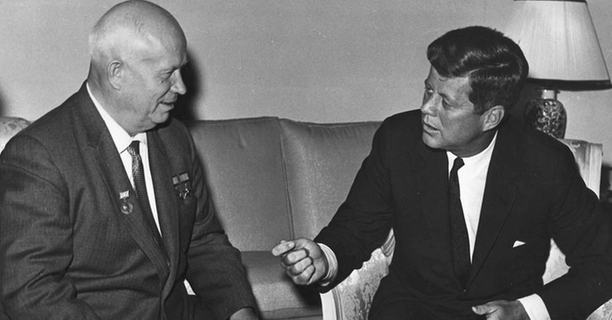

Reactions to the Ultimatum

At the summit in Vienna, little progress was made, neither Khrushchev’s bullying or Kennedy’s charm had much effect on the other. After two days of berating Kennedy, Khrushchev gave him another six month ultimatum and then both men left for home. Six weeks later Kennedy had a press conference; a superficial viewing of it shows typical Cold War saber-rattling, but a closer analysis shows that Kennedy was offering Khrushchev a way out. Kennedy promised that NATO would use all the force it had to defend the rights of the 2 million West Berliners; by distinguishing the West from the East of Berlin, he was thus implying that he would take no action if the Soviets restricted the freedom of movement of its own citizens. Khrushchev admittedly missed the carrot that Kennedy was dangling, instead visiting the ballet that night to find the British Ambassador to remind him that six bombs would be enough to destroy Britain.

At the same time, pressure in East Germany was increasing as departures increased to 25,000 a month (only 15% were stopped by the new GDR measures). Whole factories and offices were forced to close as people fled before the ultimatum expired. Ulbricht was doing all he could to inflame the situation, issuing threatening press conferences in which he explained what he would do with access to Berlin; he even downplayed rumors that a wall was being planned (rumors that none had even heard of). In early July, Khrushchev, finally broke and gave Ulbricht permission to begin to implement his already sophisticated plan to seal off West Berlin.

In late July, the Americans gave a more blatant signal to the USSR when the head of the Senate Committee on Foreign Affairs, William Fulbright, asked why the Soviets were not simply closing off their own borders. In order not to provoke the West any further, Khrushchev took the planning firmly away from the East Germans, who were planning to sabotage West Berlins airports so all air traffic had to go through Schonefield. He also ensured that not a milimetre of the wall was on West German territory. In order to ensure solidarity Khrushchev held a meeting for Warsaw Pact members to stand with the GDR, especially if economic sanctions were imposed. The members however were far from accommodating, complaining of their own financial situation and fears of themselves receiving sanctions if they stood with the GDR. Most blamed Ulbricht for his current situation and were unwilling to offer any practical help.

The US began to make preparations after the Warsaw Pact meeting in August. Kennedy’s National Security Advisor, McGeorge Bundy, drew up plans to prepare a plan for destabilizing East Germany to provoke a potential uprising. Although he realized there would be little prospect for success, he planned to have it leaked through counter-agents in East Berlin before the Soviet Communist Party congress in October. Clearly the US did not realize how advanced the plans for the Wall were; in consultation with Britain, France and West Germany it was agreed that no plans would be made before the Soviet Party Congress. By 2 August, restrictions and searches of workers who lived in East Berlin but worked in West Berlin were increasing; which saw nearly 2,000 a day make applications at the Maddienfield Refugee Centre. By now the CIA was beginning to get reports of the borders permanent closure. Through differing sources, the US learnt that 14,000 troops and police had been mobilized to close the border on the following Sunday (when many in the city would leave for the surrounding lakes and forests). Still the US and Mayor Willy Brandt made no move; the general feeling being that Berlin was to integrated to be split.

Why eventually did Khrushchev decide to build the wall?

Summary of Reasons it was Built.

|  |  |  |
| --- | --- | --- |
| Economic | US Actions | Political |
|  |  |  |

The Wall Goes Up

At midnight on 13 August 1961, the closure of the border begun. By dawn, 78 of the 81 points of access had been closed including all railways and U-Bahn lines. The West was caught off guard, the British and American armies were not mobilized and the lightly armed West German police were powerless to do anything. As the barbed wire was rolled out, the Americans still made no move. Indeed at this time, the American’s biggest fear was that East German’s would try and storm the guards, triggering a massacre that would force them to act. It was only after a meeting with Willy Brandt later in the day, which he accused them of cowardice and appeasement did they agree to step up their patrols. Some West Berliners did try to remove the barbed wire and pelted the East Berlin guards with stones, but West German police quickly stopped them.

The main reason for a lack of movement was the poor communication between Berlin and Washington. It took a full eight hours for any message about the construction to reach Washington, but no reply could be given as the phone to the Berlin mission passed under East Berlin. Aides were also unwilling to wake President Kennedy who was on holiday and unwell, even so he still did not receive any word about events in Berlin until after he had attended Mass and then taken a boat trip for a luncheon. By the time he had received word it was nearly 18 hours after construction had begun. Kennedy was keen to avoid any confrontation, carefully drafting a press statement which said the wall was a measure to prevent the exodus of refugees from East Germany which violated existing agreements and that the USA would be making protests through appropriate channels. This protest was not issued for another four days and crucially it did not demand the removal of the wall.

Harold Macmillan was similarly leisurely when confronted with the news, continuing to hunt Grouse all Sunday as he had done the day before. Britain had no desire to become embroiled in a conflict over Berlin, they had issues in Iraq and Kuwait and were trying to cut their military commitments in West Germany who had recently overtaken them economically. De Gaulle in France, declined to cut his holiday short. Despite his rabid dislike of the Soviets he would not intervene in Berlin in the midst of a costly war in Algeria.

The USA did not have enough support from NATO to potentially go to war over Berlin, especially as access had not strictly been forbidden; you just now required a visa (which would in actuality be only given to a handful of party functionaries). The Allies also had no cause belli for war; they knew from their spies that East Germany was calm and that the Soviet Army was remaining in a defensive position. Kennedy ultimately rationalized his inaction by saying ‘a wall is a lot better than a war’ and ‘This is the end of the Berlin crisis – the other side panicked not we’. Eventually in order to quite the opposition coming from West Germany, Vice President Johnson was sent to Berlin (where 800,000 turned out to greet him) to announce that the garrison would be strengthened with an extra battle group and that the garrison would be under the command of the famous General Clay. Eventually Kennedy himself will visit Berlin to show solidarity in June 1963, where he famously said ‘Ich Bin Ein Berliner’

Why was the West so accepting of the Wall?

Those who had lived in East Berlin but had previously worked in the West faced discrimination, 24,000 of the 32,000 were found work but they were not allowed to hold any power or work in crucial industries. Anyone who was studying in West Berlin were immediately put into unskilled factory jobs. School students who had been studying in the West were immediately scattered amongst schools all over East Berlin for fear that they may ‘contaminate’ East German students. Senior High School students were forbidden from finishing their education and were instead given apprenticeships.

Local parishes were completely separated and for some their whole social life was disrupted. Families were often completely split up and many couples were not able to see each other for another 28 years. Many in West Berlin had preferred to drink and socialize in the more bohemian East and now this was completely impossible. Those deemed to be politically subversive (Around 7200) were imprisoned in the Hohenschonhausen. Eventually 239 people were killed trying to cross the Wall, while around 5,000 managed to escape. It should also be remembered that many East Berliner’s supported the building of the Wall; many had become bitter at those who were able to work for Deutchmarks in the West, which with the exchange rate allowed them to earn 25 times more than they could in the East, yet they still had access to Communist provided services.

What were the impacts on the people of Berlin?

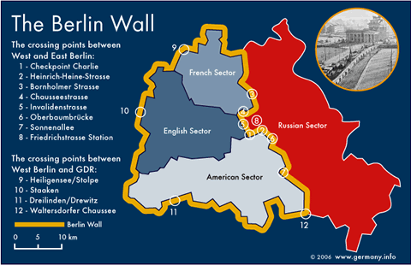

Who did it Benefit?

|  |  |
| --- | --- |
| Soviet Union | The West |
|  |  |