Japan

Reasons

Actions Taken

Hitler – Reparations

Reasons

Actions Taken

Hitler – Population and Territorial Losses

Reasons

Actions Taken

Why did some countries in the 1930s remain dissatisfied by the peace treaties of 1919–23?

Mussolini

Reasons

Actions Taken

Hitler – Restrictions on Armed Forces

Reasons

Actions Taken

Hitler – Anschluss

Reasons

Actions Taken

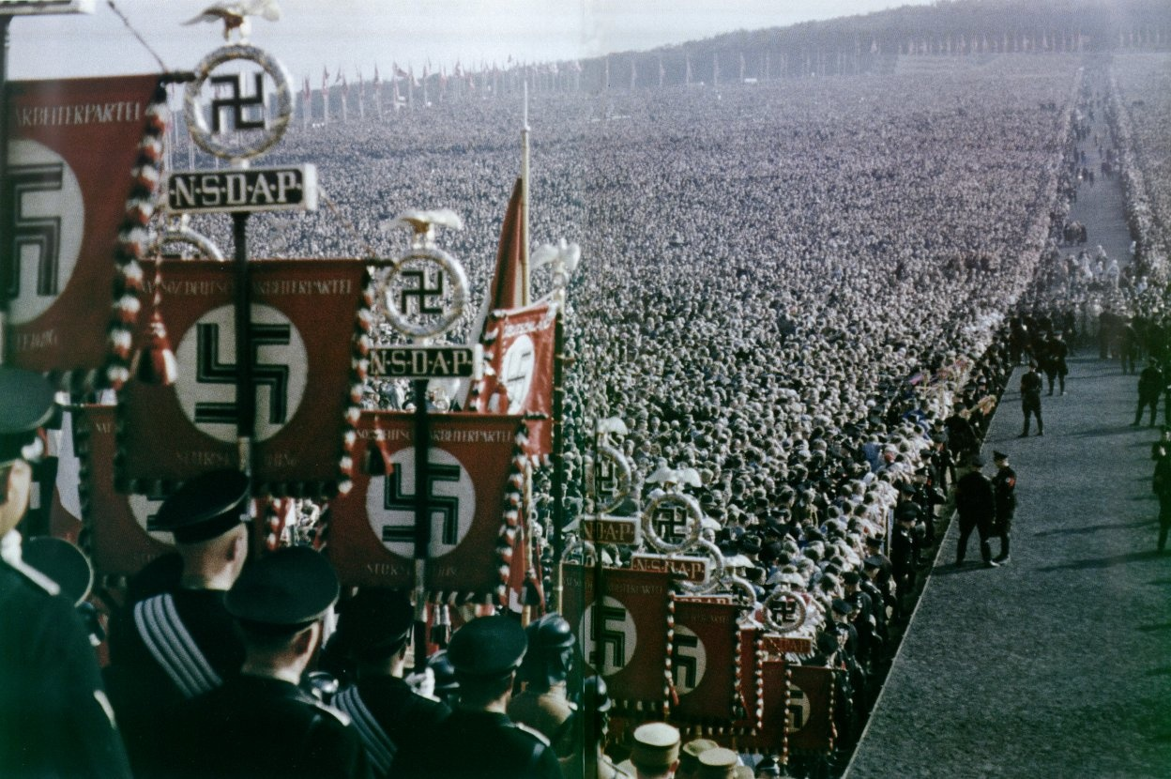**Glossary for the Reading**

Teutonic

Liberalism

Ideology

Weimar Germany

Rhetoric

Credence

Exponentially

Decadent

Subjugation

Hubris

Anglophobic

Encapsulate

Operation Sea Lion

Barbarossa

Apotheosis

Hossbach Memorandum

Pacifism

Insurmountable

Popular Front

Malaise

Chamberlain

Vitriolic

Munich Conference

Prague Coup

Anglo-German Naval Agreement

Comintern

Mein Kampf

Collectivisation

Molotov-Ribbentrop Pact

Molotov

Culpability