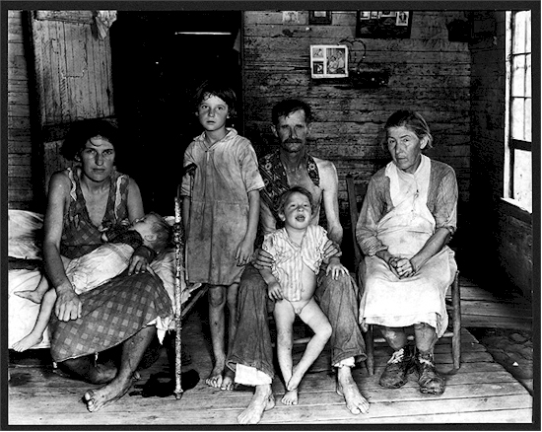**__________________________________Why did the Great Depression Make the Work of the League of Nations Harder?_______________________________________**

Capitalism =Democracy

Failure of Capitalism = Democracy is a flawed system

**Democracy = League of Nations**

Soviet Union = No Depression

**Greater Government Control = No Depression**

No Jobs = No need for unions

Unionsim = ILO

No Demand = No Trade

No Trade= Protectionism

**League of Nations = Trade Between Nations**

**No Trade= No economic sanctions**

Economic Prosperity = Control of Resources

Control of Resources = territorial Expansion

**League of Nations = Resources for Britain and France**

Great Depression = Loss of Income for Governments

No Money = Cuts to the Armed Forces

**League of Nations = Collective Security**

No jobs = social unrest

Social unrest = fear

Fear = militaristic governments

**League of Nations =** Disarmamanet

Failure of Capitalism = Demands for welfare

Demands for Welfare = Left wing governments

Left wing governments = Reduction in military spending

**League of Nations = Collective Security**