**______________________________________**A Call to Arms**_______________________________________**

What consequences of the First World War do we still live with?

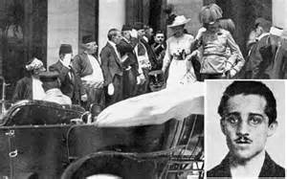

Why were the Balkans so problematic?

What problems were there in Austro-Hungary?

What problems were there within Serbia?

What changes did Franz Ferdinand propose? Why would this be a problem for Serbia?

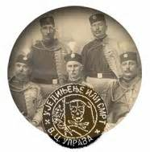

Did the assassination go to plan?

Who was blamed for the execution?

What extraordinary oversight did the Germans make?

How did Austria’s ultimatum make war very likely?

How did the crisis catch everyone by surprise?

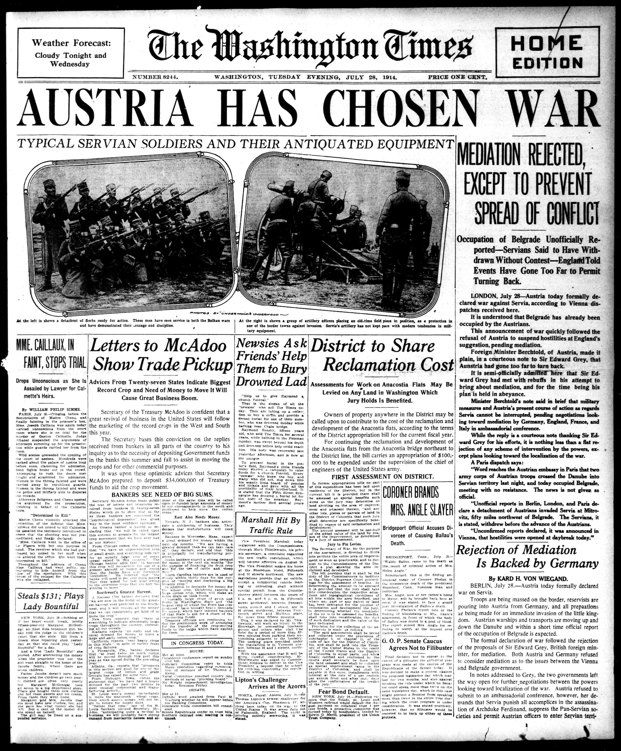

What did all the Great Powers believe?

How was Britain different and why then did it go to war?

How did the war confound expectations?

