________________________Japan and the First World War_____________________

Japan quickly recognised the slight risk and considerable gain in joining the Allies as a b____________. Many in the military were frustrated that Japan had not seized southern Manchuria in the chaos following the fall of the Q_____ in 1911. If Germany were to win the war, it would likely attempt to expand its interests in areas of vital interest to Japan – China, and T_________.

Japan m________ its navy as soon as Britain declared war on Germany on 4 August 1914. Even as Japanese sailors braced for a possible showdown, Japan’s c___________ shipping came under immediate assault. A battlecruiser from the German Asiatic Squadron based in Qingdao, China, apprehended the Daitomaru upon its return to Qingdao on 4 August and boarded it for inspection. Although it was immediately released, the daily Nihon could not determine the fate of another Japanese ship from Hong Kong detained by the Germans in Qingdao on the same day.

On 6 August, the US cautioned Tokyo that, in the event of combined Anglo-Japanese military action against Germany, American naval power would have to be deployed in Asia to protect American commercial interests. When Japan demanded that Germany transfer its Chinese concessions to it and Berlin refused, the Japanese launched an attack. After Germany demanded sovereignty over the L_____________ Peninsula, Japan declared war on 23 August.

On August 15, the Japanese Foreign Minister, Kato Takaaki, issued an eight-day ultimatum to Germany.

Considering it highly important and necessary in the present situation to take measures to remove all causes of disturbance to the peace in the Far East and to safeguard the general interests contemplated by the agreement of alliance between Japan and Great Britain, in order to secure a firm and enduring peace in Eastern Asia, establishment of which is the aim of the said agreement, the Imperial Japanese Government sincerely believe it is their duty to give advice to the Imperial German Government to carry out the following two propositions:

(1) To withdraw immediately from the Japanese and Chinese waters German men-of-war and armed vessels of all kinds and to disarm at once those which cannot be withdrawn;

(2) To deliver on a date not later than 15 September 1914 to the Imperial Japanese authorities without condition or compensation the entire leased territory of Kiaochow, with a view to eventual restoration to China.

**With reference to its origin, purpose and content, analyse the value and limitations of Source H for an historian studying Japan in the First World War.**

Japan’s p________ goal, in fact, was to expand its interests in China while the major powers were preoccupied in Europe. Japan’s greatest reward would be kicking German interests out of Asia altogether and establishing itself as the d________ foreign power in China. For this fight to win Chinese territory, Japan contributed much larger forces than Britain. For instance, 2,800 British and 29,000 Japanese troops engaged the Germans at Q________. The defenseless P______islands were seized by the Japanese navy without bloodshed.

The Allied powers wanted Japan to dispatch troops to E________; in 1915, France made informal requests for up to 500,000 Japanese troops to be sent to the B________

Peninsula. However, the Japanese government limited its military cooperation to sending convoy-escort destroyers and submarines to the M________. It stalked German converted raiders operating in the Pacific and protected convoys of A_________ and New Zealand troops from the Pacific to Aden. It also provided desperately needed shipping, copper, munitions (including 600,000 r________ to Russia) and almost $640 million in loans to its allies.

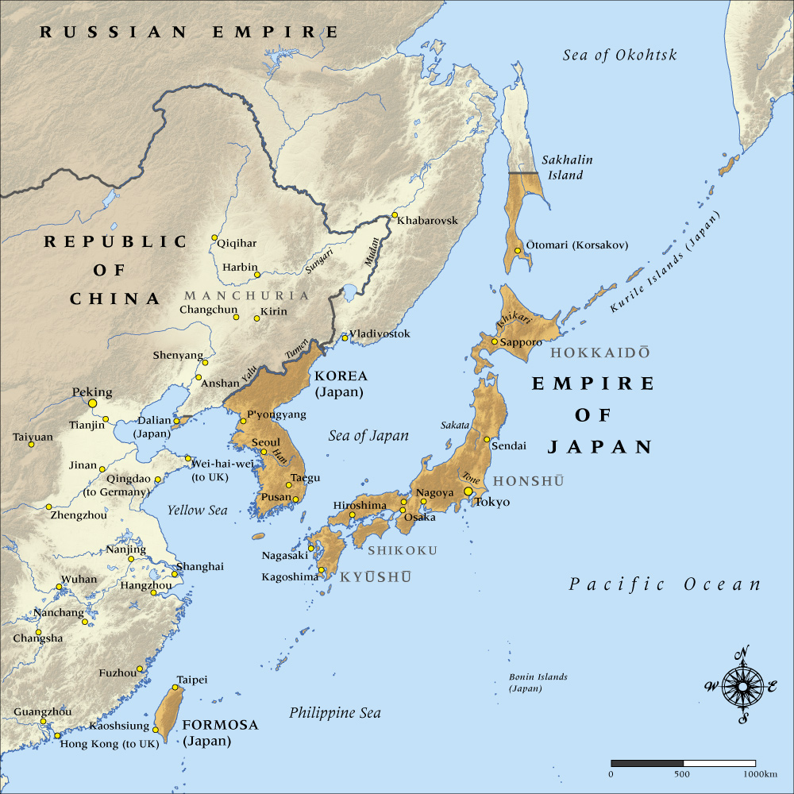

Once the first objective of taking Qingdao had been achieved, Japan’s next goal was to set itself up as the dominant force in China. As the Europeans exhausted each other in battle, Japan’s support (and its threatened withdrawal) became the critical card it played to ensure it would have a free hand in East Asia. In January 1915, it presented 21 infamous d_________that aimed to turn China into another K_________. The fifth was the most serious and demanding section, which requested that China appoint Japanese advisers in political, financial, and military affairs and allow the Japanese to take control of police departments in crucial places throughout China.

The Japanese clearly meant to make China a v________ state and calculated that time was on their side since the major powers were fighting for their own survival and would not have the energy to spare for the sake of China or their own interests there. Japan had to back off from the 21 demands when US Secretary of S_______ William Jennings Bryan sent a strong note indicating that the United States could “not r_________” them. These aggressive demands also caused disquiet amongst Britain and its D_______, who felt the Japanese contribution to the First World War hardly warranted such rewards.

To limit Japanese influence, China began actively supporting the allies. From 1916 onwards, China provided 140,000 workers who l________ on the Western Front during the war. Of all the foreign countries involved, China sent the largest number of workers to France, and the Chinese stayed there the longest. China did not officially join the war until 1917. Its declaration of war on Germany and Austria–Hungary might not be considered s__________ in world affairs, but it was an extremely important event for China. This was the first time in modern history that the Chinese government took the initiative to play an active role in affairs distant from its shores. China’s participation was also the first time in modern history that China had come to aid the W______ on any significant scale.

The Japanese e________ boomed. The boost in foreign trade thrust Japan’s balance of payments into surplus for the first time in Japanese history. A series of loans to China from 1917 gave Tokyo brief but significant new political and economic leverage in Beijing (Nishihara loans). As the war in Europe approached an end, the situation became more favorable to Japan’s continental policy. In 1916, a 156-ship (300 million) expansion of the navy was a_________. The United States entered the war in 1917, and the Russian R__________ erupted. Given the likelihood that the Western powers would return to A______ after the war’s end, many Japanese leaders were anxious to gain as much ground as possible.

The Russian Revolution was a great s_______ to the Japanese. Russo-Japanese relations had improved remarkably, with several conventions clearly d___________ each other’s spheres of influence. It was Wilsonian l__________ that Japan perceived as the biggest challenge to its imperial ambitions. The loss of a like-minded power to the West caused concern. Still, the opportunity to increase their continental presence outside international treaties caused excitement, especially amongst the army, which had suffered in the f_________ war with the navy with the Russian rapprochement.

In the summer of 1918 the Terauchi government sent a force of seventy thousand to Siberia as part of the Allied intervention in the Russian Revolution. Significantly, Japan committed the most forces, and its forces stayed the l_________ (primarily as their troops could only remain in China if hostilities continued). The Terauchi cabinet also concluded a joint defence treaty with China under the pretext of preventing the spread of revolutionary currents from Russia to the Far East. By the time the First World War ended in November 1918, Japanese military forces were able to operate in a zone that extended from Lake B_______ in the north into the hinterland of Sinkiang Province to the West and as far south as the former German-held island territories in Micronesia to the south. It was an area almost e_________ in extent to the regions occupied by the Japanese forces in 1942 in the Pacific War.

However, the Siberian intervention was scarcely a success. Rather than unleashing a wave of nationalism, instead riots involving two m_________ Japanese erupted over the inflation caused by the intervention. Japanese intervention in the war was limited. They also fell out with their foreign allies by supporting Grigory Semyonov, who wanted a pro-Japanese independent S_________, while the Europeans and the US-backed Alexander Kolchak who operated out of the Don region. After the Red Army defeated Kolchak in early 1920 and the sizeable Czech force evacuated, enthusiasm for the expedition from the Western powers dissipated. Japan withdrew from Siberia but occupied the remainder of S_______ Island.

The army and navy had become p_________ due to the victories of the Sino-Japanese War and the Russo-Japanese War and this had attracted many young men to join their ranks, but this now tailed off. The lax discipline of troops in Siberia curtailed public support for liberalism and democracy. Some privates from poor rural areas who entered the army as a result of compulsory military service s_____________ with Communism or anarchism and accused the army of discrimination against outcasts. These soldiers’ radical behaviour sometimes made it challenging to maintain d__________. Accordingly, the army realised the importance of education for officers as liberalism and democracy spread.

