League of Nations Dispute 1923

**Memel**

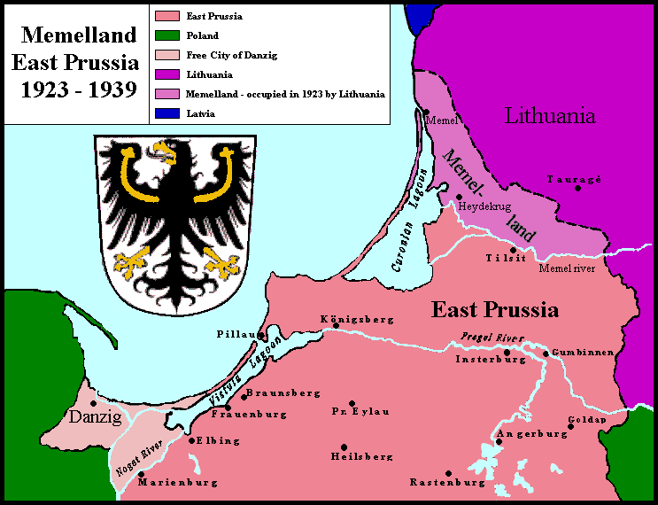

**Disputers**

Lithuania and the League of Nations

Size

2848 km2

Population

150,000 (75,000 German, 65,000 Prussian Lithuanians and 10,000 Poles)

History

  This area was disputed by both Poland and Lithuania at the Paris Peace Conference. It would offer Lithuania its only sea port.

  Because the dispute could not be solved it was administered by the League via France in 1920. Most Germans did not want to become part of Lithuania but realized it would not be returned to Germany.

⬥ In 1922, the British suggested that Lithuania have Memel in return for giving up Vilna. The Lithuanians rejected this and the League then decided to keep Memel as a free city (which 75%) of the population had voted for at the end of 1921.

⬥ In November 1922, the Lithuanian President planned a local revolt to try and remove the French

⬥ On January 10 1923, just over 1000 Lithuanian militia men equipped by Germany joined 317 men revolting in the port. They skirmished with the 250 French guarding the city, killing two men.

⬥ The British caution the French not to retaliate, fearing the Soviet Union may offer aid to Lithuania. Poland offers to remove Lithuania from the city.

