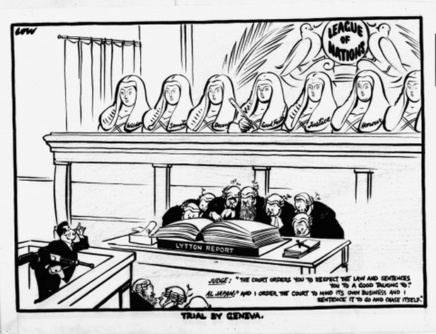League of Nations in the 1930’s

**Group Revision**

How did the Depression destroy the League?

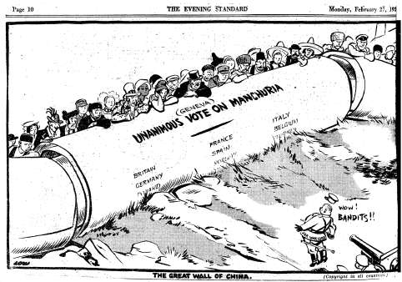

Why did the League fail in its peacekeeping role in Manchuria?

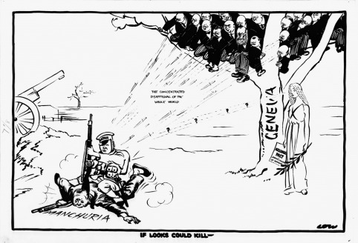How did a lack of an Army effect the ability of the League in Manchuria?

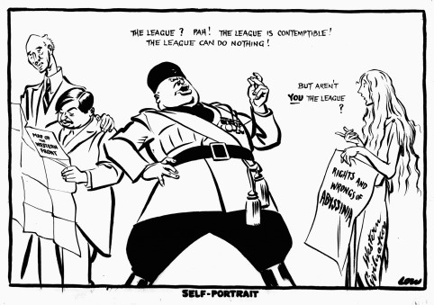

Why did the League of Nations fail in its peacekeeping role in Abyssinia?

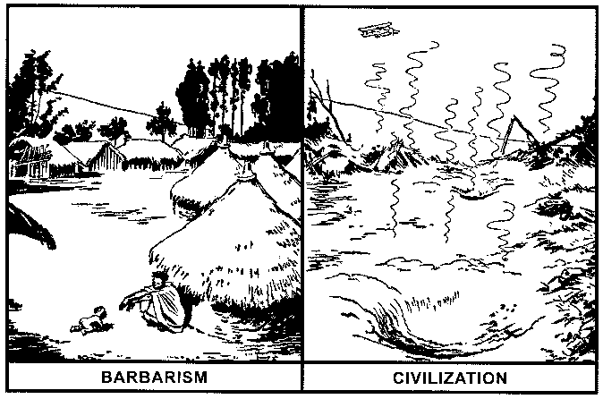How did the Hoare-Laval pact destroy the League?

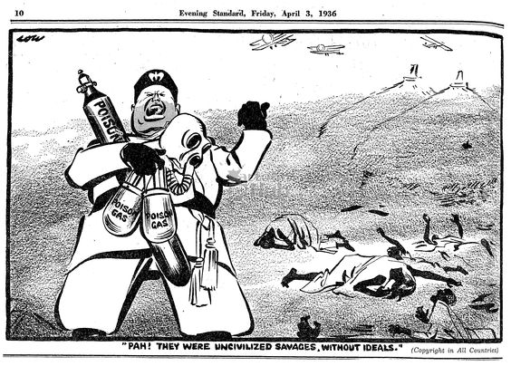

How were Britain and France responsible for the failure of the League of Nations?