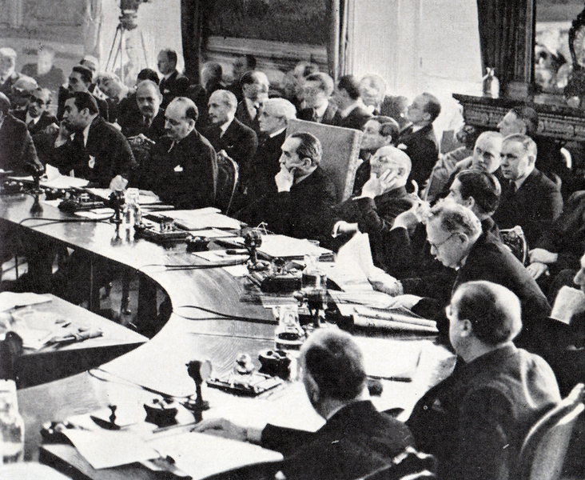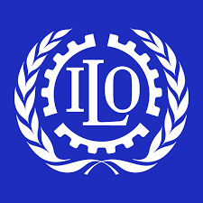 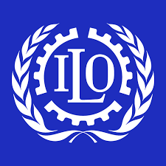

Economic Committee

Austria

Eastern Europe

Conferences

International Labour Organisation

Improvements in Workers Conditions

Improvements in Worker Safety

Women and Children

Limitations

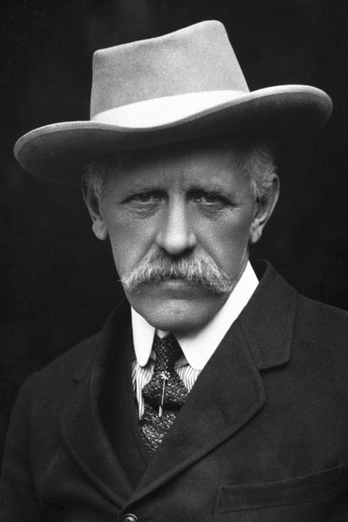

Refugee Organisation

Importance of Fridtjof Nansen

Russia

Jewish Refugees

Other Achievements

Lasting Significance

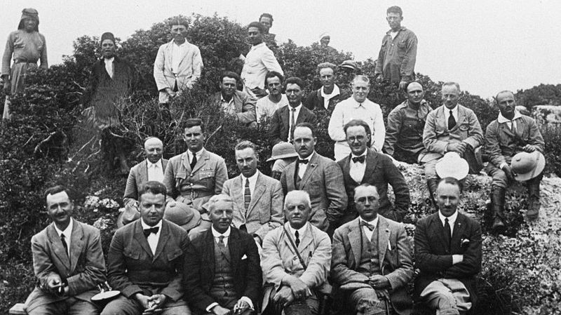

Slavery Commission

East Africa

Other Regions

White Slavery

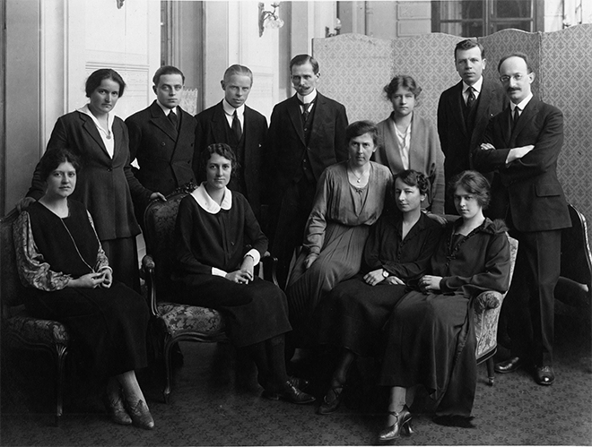

Health Organisation

Research

Disease Eradication

Campaign Against Drugs