____________________________________________Major Terms of the Treaty of Versailles: Summative Assessment____________________________________________

|  |  |  |  |
| --- | --- | --- | --- |
| **TERM** | **WHO WANTED IT** | **EVIDENCE FOR** | **EVIDENCE AGAINST** |
| **WAR GUILT**  Article 231: The War Guilt Cause. Germany had to admit all responsibility. | This would later prove to be the most controversial of the impositions. But was needed in order to impose the other indemnities. All the allies were in agreement. | Germany gave the Blank Cheque to Austria.  When Russia mobilised Germany declared war on Russia **and** France | Serbia was a rogue state  Russia was the first to mobilise  Germany was not threatening Britain |
| **REPARATIONS**  Article 232: Imposed war indemnities on Germany. These were eventually set in 1921 at £6.6 billion (2500 billion RMB in 2022). | All agreed that the Germans would pay reparations to the Allies. They also agreed that the German’s total damage in France was **£3.2 billion**.  The USA felt that only the German damage should be paid. The British and French felt that the Germans should absorb the war’s entire cost along with future medical bills and widows pensions.  The British needed France to receive money they had borrowed yet realised that Germany would be their major trading partner. Britain also had to replace its Merchant Navy that was destroyed by the U Boats and ensure Germany could not threaten Britain again. By 1921 interest and further loans meant that they owed the USA £900 million more than the end of the war. Knowing they would only get 25% at most of the entire total, Lloyd George asked for **£11 billion** in December 1918. As the negotiations progressed, this figure was revised down as they feared a vengeful Germany.  The French were prepared to accept **£4.5 billion** if they got the majority of the money. France did not want to be too excessive as if they alienated the British then they would demand more, as they had spent the most on the war. By January 1919, the USA and French advisors to Wilson and Clemenceau agreed on a figure of **£5.9 billion**.  The USA offered no relief to its allies war debt | Germany had imposed reparations on France in 1871 at 200,000,000 francs. (£515 million in 1919 money)  Germany had deliberately kept taxes low during the war. Instead it issued war bonds, which it intended to pay with the indemnities it would impose on the allies.  In 2014, Adam Tooze calculated that the reparation payments took 3.6% of the German national income between 1921-1933. | Germany had signed the armistice on Wilsons idea that there would be no punitive peace.  John Maynard Keynes (the preeminent British economist) wrote an influential book in 1919, *The Economic Consequences of the Peace*, arguing the reparations were beyond Germany’s ability.  In May 1919, the Germans who knew of the terms but had not signed, offered to pay £4.5 billion, but they stipulated that it would be an intial payment in Gold followed by `£50 million a year for the next 80 years. |
| **ARMY**  The German Army must be kept to 100,000 men.  The navy was to be 15,000 with no ships over 10,000 tonnes  No artillery, tanks or air force. No imports of weapons.  Police had to remain at pre-war levels and no cadet training. | France wished to limit the German army to 140,000 conscripts, serving for a year.  Britain wanted an army of 200,000 volunteers.  America abstained from these discussions.  All agreed that U-Boats were to be banned. The German navy had already scuttled itself at Scapa Flow. Britain was more worried about American naval building. | Germany was militaristic, it will bring peace.  It reduced Germany’s expenses. The reparations schedule of payments was far below the £195 million that Germany spent each year on the military prior to the outbreak of the war.  Germany had no immediate threats. | Germany could not protect itself.  A resurgent Russia (USSR) could eventually threaten Germany. Nobody knew if Lenin would follow through on his rhetoric about spreading Bolshevism into Europe.  Germany was in crisis. It had to rely on militias of returning soldiers (Freikorps) to subdue a Communist (Spartacists) uprising in January 1919.  Germany was the only country compelled to follow Wilson’s point about disarmmament.  For a former world power, it humiliated Germany. |
| **COLONIES**  Germany was to lose all of its colonies. Most were made mandates to the League of Nations e.g. Samoa was a NZ mandate. However Britain, France, Belgium and Japan took direct control of some e.g. Cameroon and Tanzania | The USA firmly opposed imperialism (though made no move to give up control of the Philippines). They insisted on the mandate system. | Very few Germans lived there.  No colonies were returning a profit to Germany and the First World War had proven that they were unable to be defened. | Against 14 points.  Humiliating for Germany.  Noone else gave up theirs, and the mandate system was colonialism by another name. |
| **WESTERN BORDERS**  France was to occupy the Rhineland for up to 15 years and then after that it would remain demilitarised.  The Saar was to be administered by the League of Nations for 15 years, until a plebiscite would decide its nation. Coal would be taken to France  The provinces of Alsace and Lorraine were returned to France. Eupen and Malmedy were given to Belgium. | France wanted to extend its borders to the Rhine River, which they argued provided a natural frontier against Germany. Both Britain and the USA were ardently opposed. They were eventually forced to come to France’s aid should it be attacked again. Clemenceau felt aggrieved as he did not believe that Britain and France would honour this commitment (which they didn’t).  France wanted control of this area which was the wealthiest in Europe.  All the allies agreed.  An opportunity to register protest was given in the provinces. Very few signatures were received; many feared the chaos in Germany | Germany lost no territory, this was where they invaded France and Belgium.  The Germans had destroyed the French Coal Mines, they needed a replacement.  The inhabitants of Alsace and Lorraine had not been very enthusiastic Germans.  Malmedy was Belgian. They were taken in 1809, off France. | No protection from France. Germany needs to control its own territory.  The French claims to this area were very tenuous. So tenuous that Orlando suggested that if France could annex the Saar then he should have a claim to Britain.  Eupen was German and both had been treated well by Germany. The plebisicite to decide who the provinces were to belong was not secret. |
| **EASTERN BORDERS**  Silesia (a rich Industrial area) and Posen (good agricultural land) was given to the newly created state of Poland. A corridor to the sea was created, but the important port of Danzig was placed under League of Nations. The Poles refused to use Danzig and built the city of Gdynia.  Hultschin (part of Upper Silesia) was given to Czechoslovakia. | A free and independent Poland was seen as desirable by all the allies although few were happy with the Polish Corridor. Lloyd George caled the Pole’s ‘hopeless’, he was worried about creating a new Alsace and Lorraine in the East, especially with the unstable Polish government.  The defeat of the Soviet army by Pidluski in 1920 pushed the Polish Borders much further East than the allies intended.  This received little discussion despite the fact that nearly 3 million Germans were located in the Sudentenland. | Poland needed access to the sea.  Germany gave up less territory than the USSR to create Poland.  It was in the 14 Points.  The majority of the Polish Corridor was Polish.  The Prussians had not treated the Polish population well prior to the war.  Czechoslovakia would be very poor without this area. | No one was happy, it was a strange settlement. Over half the German population in Poland emigrated.  Borders supposed to be on ethnic lines but only 51% was Czech. |
| **AUSTRIA**  No union with Austria (Anschluss) | Austrian borders were already decided before discussion took place. Very little consideration given to potential problems. As it was along clear ethnic lines then the USA happy. | Anschluss would have made Germany more powerful than before. | The new Austrian state proved to be wholly unsatisfactory. A fraction of its former size, with the city of Vienna comprising half of its 4 million population. |

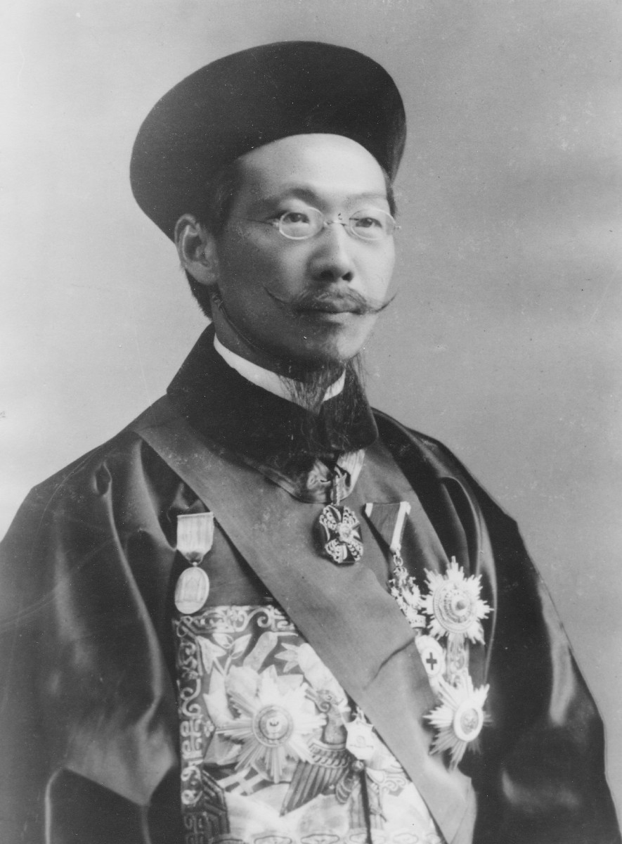 TASK SHEET

You are this man Time: Two Cycles – DUE 17 OCTOBER

Individual Work but discussion is allowed.

He is Lou Tseng-Tsiang, the Chinese Foreign Minister and the head of the Chinese delegation to the Paris Peace Conference.

It is July 1919 and you have returned from France; President Feng Guozhang is very interested in what your opinion is of the Treaty of Versailles and whether or not it was fair to Germany as he has heard that they are not to unhappy with it. He is however very much like the current US President Trump in that everything has to be simplified so he can understand it quickly.

You will need to make a clear (yes or no) decision on whether each of the seven major impositions on Germany were fair and justify why ideally in around 70 words each. You will also need to give a final conclusion in no less than 100 words or not whether or not in your opinion the Treaty was too harsh.

Marking

For each fully justified point you will receive two mark. If you can do this for each section you will get an A. You will lose a letter grade if you use an incorrect or undeveloped justification. A insightful, intellligent conclusion will turn your A into an A*.

