Tension rises in Europe: 1906-1914
First Moroccan Incident – January to April 1906
Kaiser Wilhelm visits Morocco ( regarded as being in the French sphere of influence) in order to convince them to support Germany in a war with France or Britain; Morocco vows independence. France is angry and mobilises its army; Germany responds by doing the same. At the Algericas conference which was held to solve the dispute, Germany finds little international support (only Austria-Hungary). Eventually France agrees to an Moroccan controlled police force in order for the Germans to save face. Germany’s hope of causing friction between France and Britain has the opposite effect and the Entente Cordialle is strengthened.
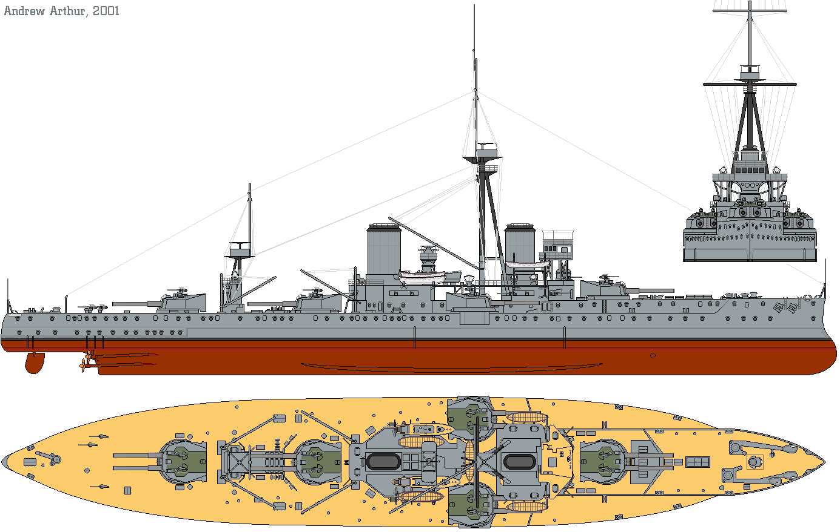
Importance
Dreadnought – October 1908
This was the first all big gun (12 inch +) battleship, that was also comparatively swift and well armoured. It sparked a naval building war between Germany between 1906-1912. British policy dictated that its Navy was greater than that of the next two powers, this meant that for every Dreadnought that Germany constructed Britain built two. This cost a great deal of money and was instrumental in the British public viewing Germany as their major potential adversary.
Importance
Bosnian Crisis – October 1908
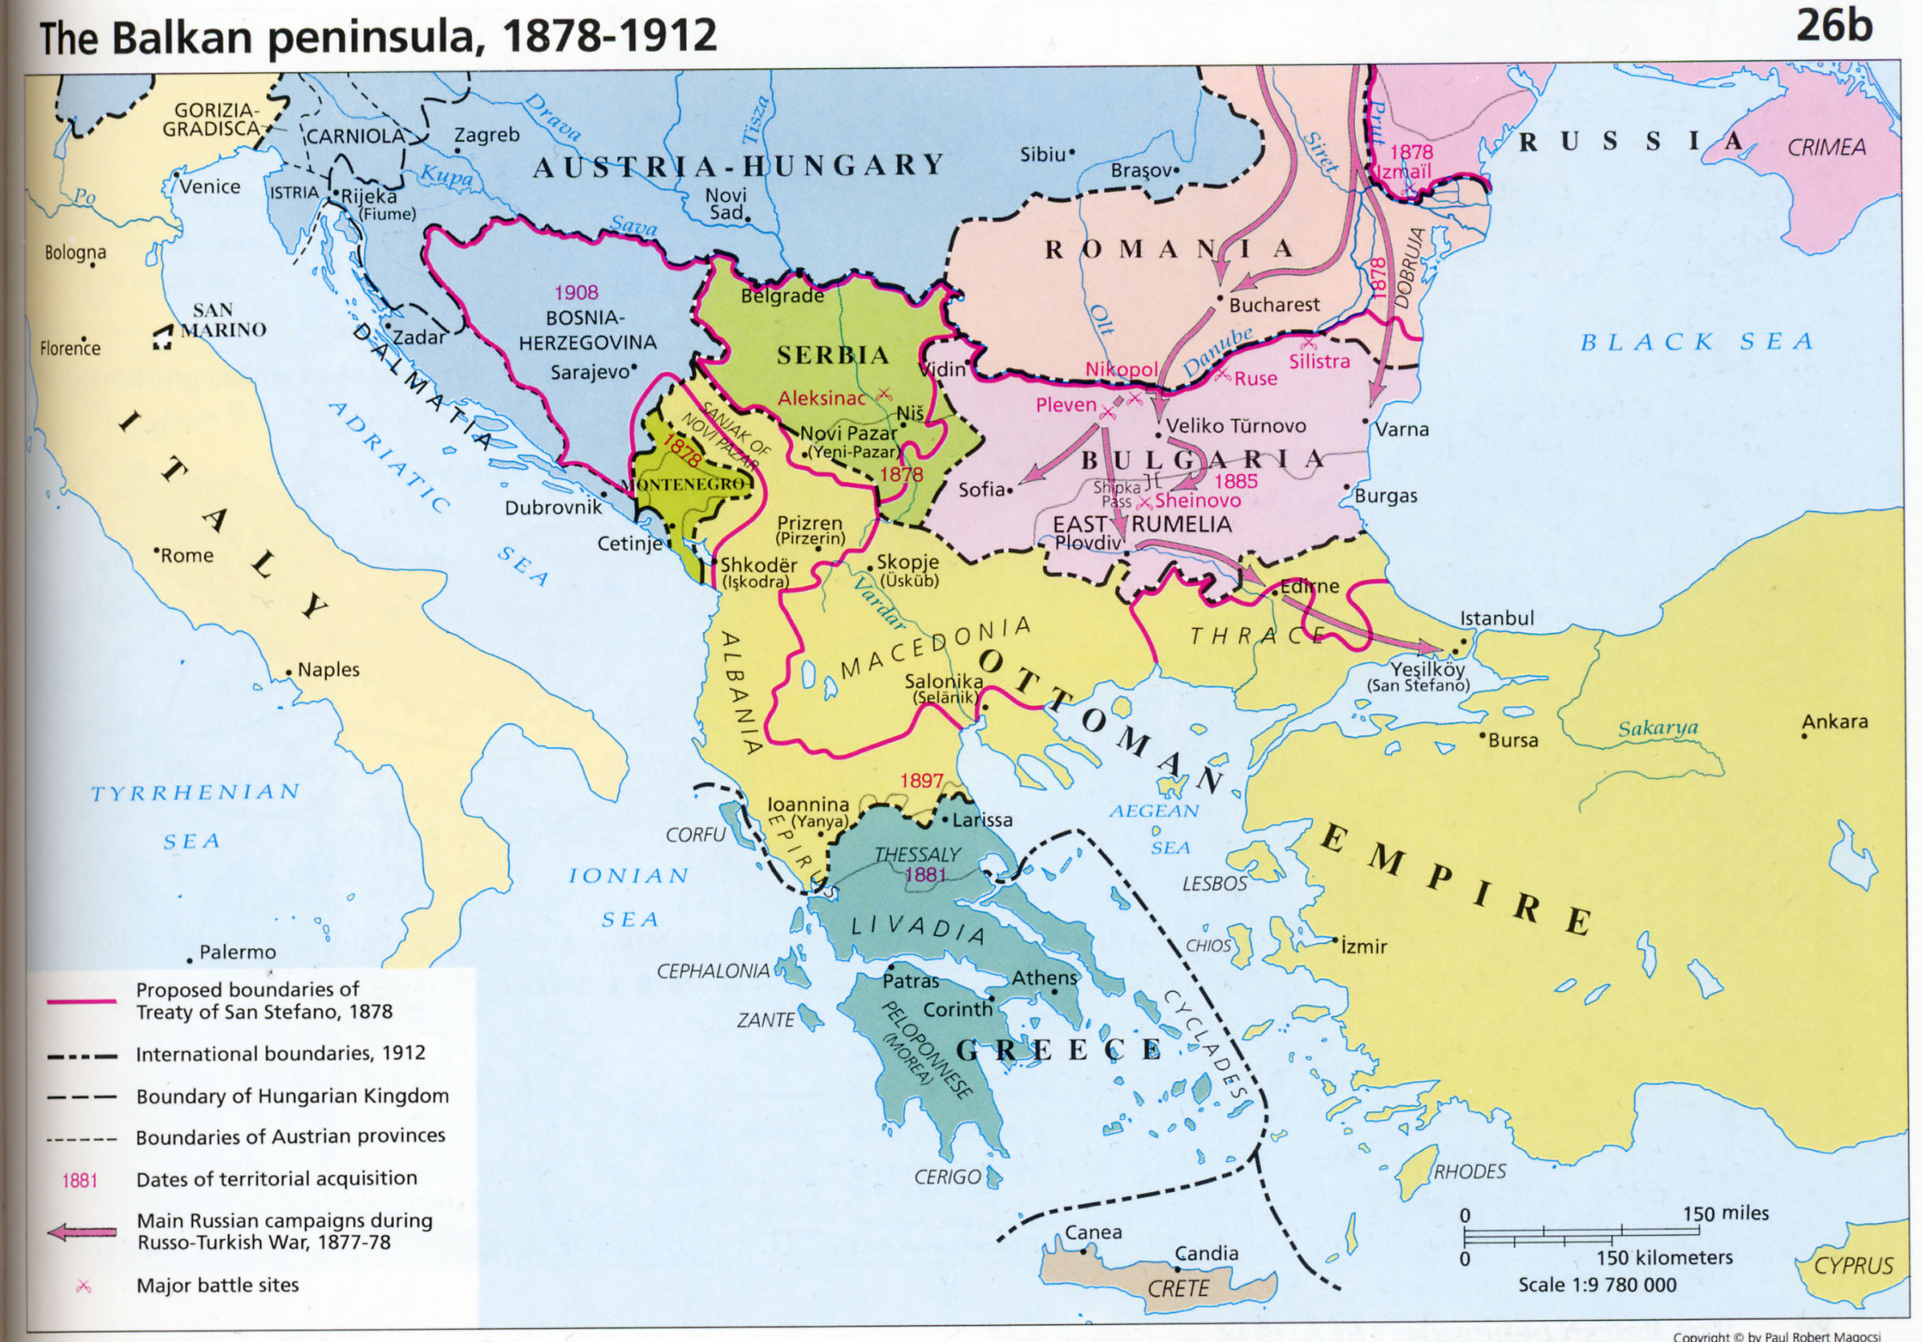
By 1908 the Ottoman Empire was collapsing and Bulgaria declares it’s independence, which alarms Serbia. All powers had signed the Treaty of Berlin in 1878 which stated that Austro-Hungary would absorb Bosnia if the Ottomans left Europe and in any crisis the Dardanelles would be closed. Serbia had not signed this treaty and objected to the annexation as Bosnia was ethnically Serb. Russia’s economy was stangled by the closing of the Straits. Russia and Austro-Hungary came to a secret agreement, whereby Austro-Hungary was to absorb Bosnia-Herzegovina and in return would support Russia in opening the Straits of Constantinople. Austro-Hungary then went back on the deal after seizing the provinces, humiliating Russia. Russia Resolves it will never suffer such a humiliation again.

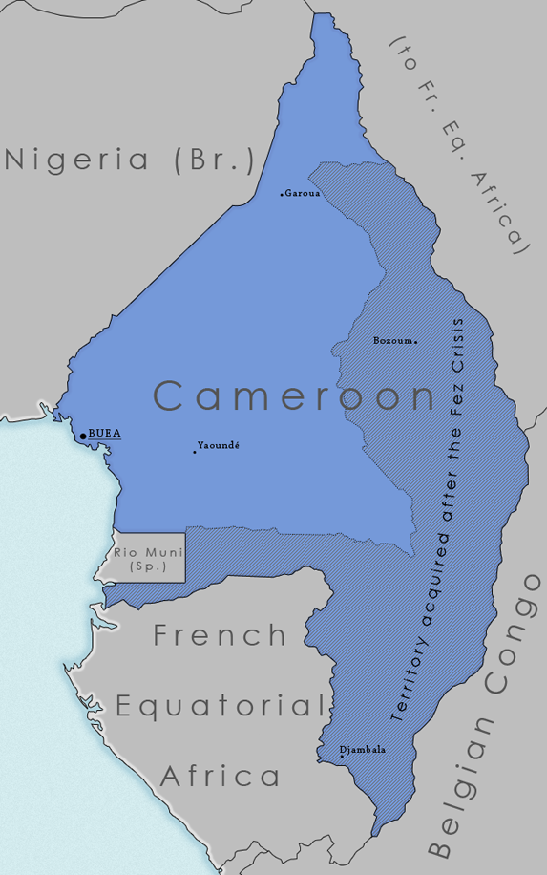
Importance

Panther Incident – April 1911
The Moroccans rebel against their leader the Sultan. France sends troops to stop the rebellion, to which Germany agrees. Germany then sends a gunboat into the harbour at Fez, which they say is to protect German citizens but was actually to show they were a great power which would have to be consulted in colonial matters. This provocative act creates a second Moroccan conference, in which France takes full control of Morocco in return for giving Germany a portion of French Equatorial Africa which was added to Cameroon. Crucially once again Britain supports France, convincing Germany that it is being surrounded by its enemies. Many in Germany now believe that negotiations are not getting them the outcomes that are deserving of a Great Power and started to look for other alternatives.

Italo-Ottoman War – September 1911 to October 1912
A short war for the possession of Italy. This emboldened the nations in the Balkans to unite to try and expel the Turks out of Europe. The war had the unintended effect of nearly bankrupting Italy, making it unwilling to join any war in 1914.

The Balkan Alliance is Complete – March 1912
Encouraged by Italy – Bulgaria (Greek ally) and Serbia (Montenegran ally) sign a secret treaty with Russian assistance. It provides for joint military action and division of conquests. Originally meant to oppose Austria-Hungary it will be first used against the Ottoman Empire
Importance
First Balkan War – October 1912 to May 1913
Bulgaria, Serbia, Greece and Montenegro form the Balkan League and attack Turkey, driving them to the walls of Constantinople. Russia encouraged the Balkan League, as it had designs on Ottoman territory and as a way to balance Austro-Hungarian power. France told Russia it would not go to war for the Balkan League and Germany cautioned Austro-Hungary.
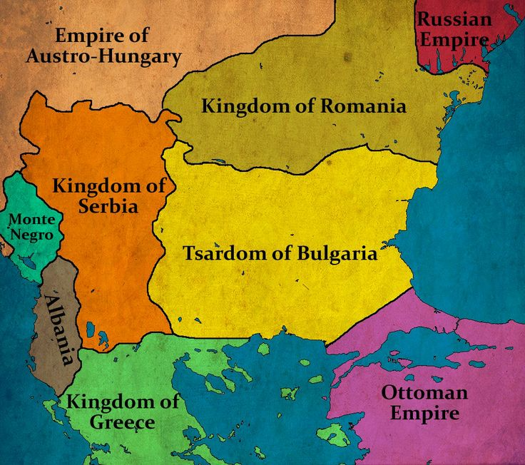
Importance
Treaty of London – May 1913
This humiliated the Ottomans, bringing the Young Turks to power. They refused to accept the terms and went to war with Bulgaria again. The Russians supported the League but Austro-Hungary would not tolerate a powerful Serbian state to its south. Eventually a compromise was reached, with the creation of Albania, to block Serbian access to the sea.

Second Balkan War – June to August 1913
Bulgaria now attacks Greece and Serbia on 29 June over a perceived injustice over territorial spoils in Macedonia. By 1 August, Bulgaria had been defeated after Romania joins the conflict

Peace of Bucharest – August 1913
Bulgaria lost territory to Romania as well as Serbia and Greece. The peace was sufficiently humiliating to Bulgaria that it could never regard the borders as final. The lack of ethnic considerations meant the area was still volatile. Crucially Serbia doubled in size.
Importance of the Balkans




