League of Nations Dispute 1923

**Corfu**

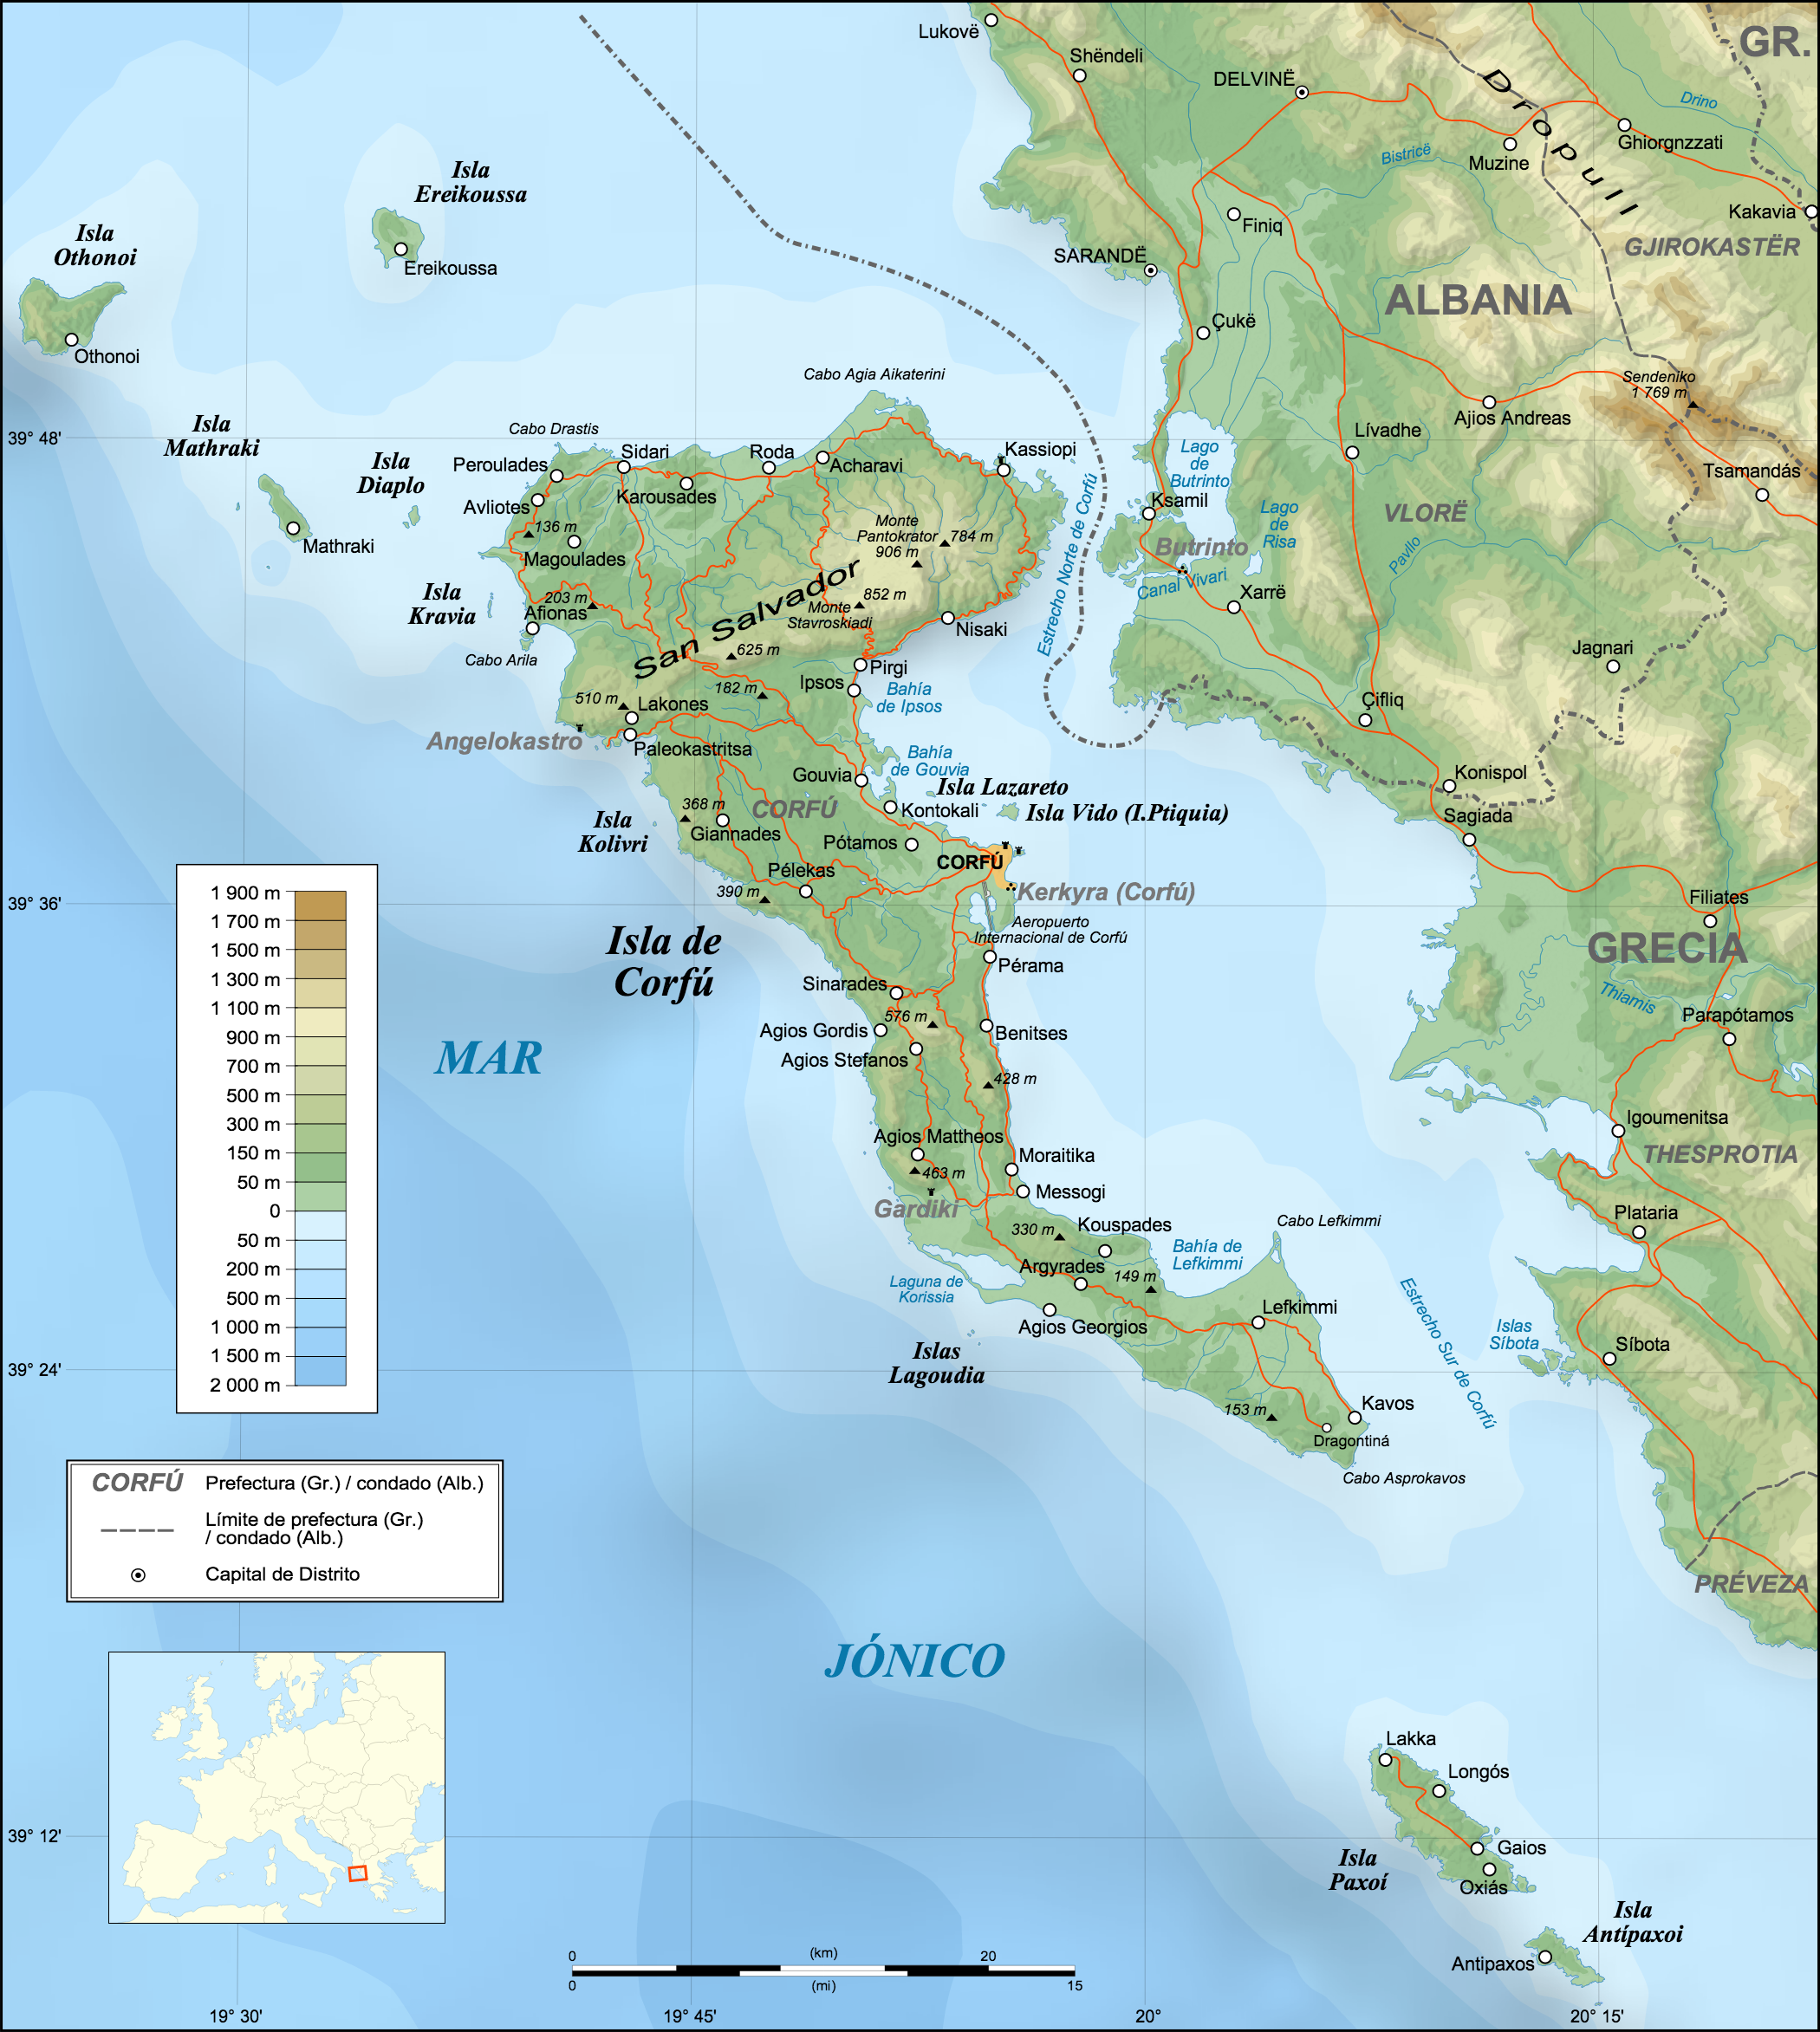

**Disputers**

Greece and Italy

Size

616 km2

Population

40,000

History

  Following the war there was a boundary dispute between Greece and Albania. The League of Nations sent a delegation to investigate led by an Italian, Enrico Tellini.

  The Greeks became frustrated with Tellini who they accused of being biased toward Albania.

⬥ While Tellini was touring Greece, he was murdered on the 23 August, possibly by Greek nationalists.

⬥ Two days later, the Italian dictator Mussolini sends a list of seven demands to the Greek Government including the payment of 50,000 Lira to Italy.

⬥ The Greek Government agrees to four of the demands, giving a funeral in Athens with members of the government attending and paying military tribute to Tellini.

⬥ The Greeks refuse to pay the money to Italy, instead offering to make retribution to the victims families, they also refuse to apologise instead offering their sorrow and they will not allow an Italian legation to conduct an inquiry instead allowing them to offer assistance.

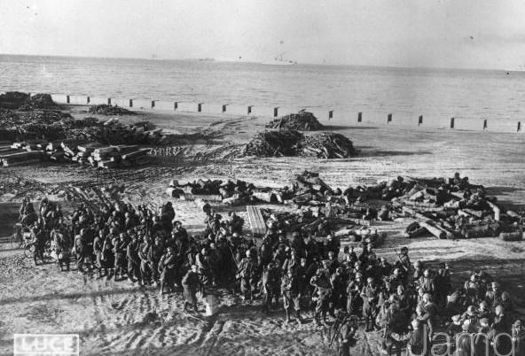

 Two days later, Italian warships bombard the island of Corfu (killing 16 Civilians), between 5,0000 and 10,000 troops occupy the island.

 The Greeks removed their warships from the area and on September 1 they asked the League of Nations for assistance.