League of Nations Crisis 1923

The Ruhr

**Disputers**

Germany and France

Size

4,435 km2

Capital

Essen

Population

3.8 million

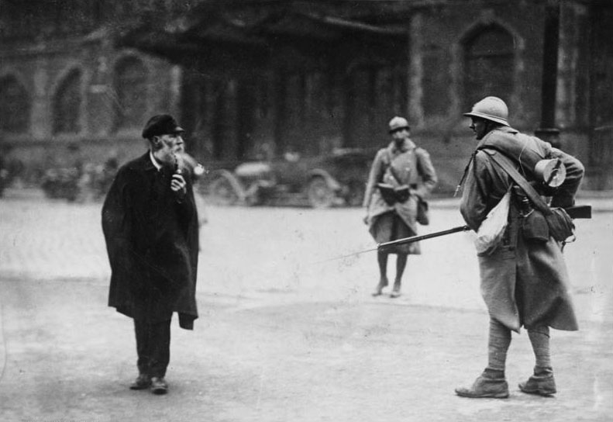

History

  In 1923, the French sent troops to occupy the German Ruhr territory, as a response to the failure to make reparation payments under the terms of the Treaty of Versailles. This move was opposed by the British who wished to see the amount of reparations reduced; the British are refusing to impose economic sanctions on Germany.

  France believes that Germany can pay, that they are trying to test the Allies to see if they will enforce the Treaty of Versailles (they had made the estimates for the amount of timber they could provide themselves and had only met two of the 36 coal deliveries). President Poincaire, believes that if Germany is allowed to break any term of the Treaty of Versailles, then it will embolden them to do more and eventually cause another war.

 France had spent heavily to repair its industry and was in danger of defaulting on its loans to the USA unless it gained these reparation payments. Britain refused to sympathise with France as it had not significantly reduced military spending.

⬥ Fritz Thyassen has organized a passive resistance

campaign to object to the occupation. The French have brought in their own workers to work in the mines and the factories resulting in violent clashes.

⬥ The German economy is now in free-fall with hyper-inflation decimating the savings of the population. This has been accelerated by the German government printing too much money to pay the striking workers.

⬥ France will not accept any payment other than raw materials due to the state of the German currency. France is refusing to negotiate with the German government.

⬥ 130 German civilians have been killed by the occupying French forces

  The Weimar Republic is now under serious threat, with an attempted coup in Munich and even the Ruhr itself trying to declare independence.