League of Nations Dispute 1921

**Upper Silesia**

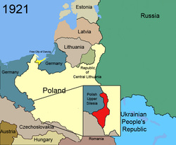

**Disputers**

Germany and Poland

Size

10,360 km2

23% of Pre-War German Coal Production

Population

2,073,000

(60% Ethnically Polish, 40% German)

History

  This area was hotly debated at the Treaty of Versailles. It was part of Germany until April 1920, when an allied commission took over the area until a plebiscite could be held, this did not take place for another 11 months.

⬥ France and Britain were divided over this issue. France wanted to weaken Germany as much as possible, while Britain wanted an economically strengthened Germany.

  The plebiscite, was inconclusive, an overall German majority was found, but this was in the cities; the majority of the rural population voted to join Poland. France also disagreed with the results as people who had emigrated from the area but were born there were allowed to vote, and these were mainly German.

⬥ The plebiscite was peaceful and had a very high turnout, but very soon riots developed, especially when it was decided that the industrial area would remain with Germany. Britain and France both sent troops to restore order to the region.

*Polish and German Propaganda Posters*

