Extended Essay
Word Count: _ _ _ _

(Title: Subtitle)
1 Introduction
Context
  - Explicitly state your research question and provide some context that positions your question within existing knowledge
  - In relation to your research question, what theories, critical approaches, methods or factors already exist? (Language Hint: WHILE/WHEREAS/HOWEVER)

WRITE HERE:

Outline of argument
  - Provide a thesis statement/main position in response to your research question
  - State which aspects, factors or key features you will be focusing on
(MUST follow same order here as when they are presented as body paragraphs/sections)
  - (Language Hint: “This essay seeks to challenge…and instead argue that…”

WRITE HERE:

Scope
  - How have you managed to answer your research question?
    - What source material has been used?
    - What scientific, if any, have been followed?
    - What critical interpretations have been challenged?
    - Which authors, theories or methods have been used?
  - (Language Hint: “This essay will also simultaneously explore…while relying on the works of…”)
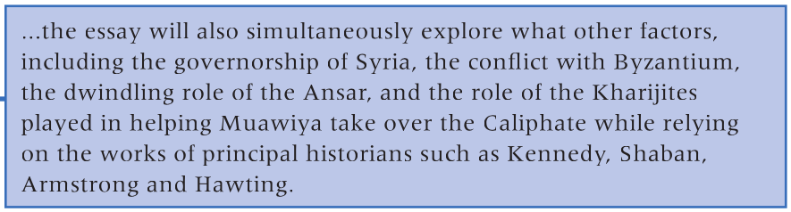
WRITE HERE:

Worthiness:
  - Why is your research question worthy of investigation?
  - (Language Hint: “This research question is worthy of investigation because…”)

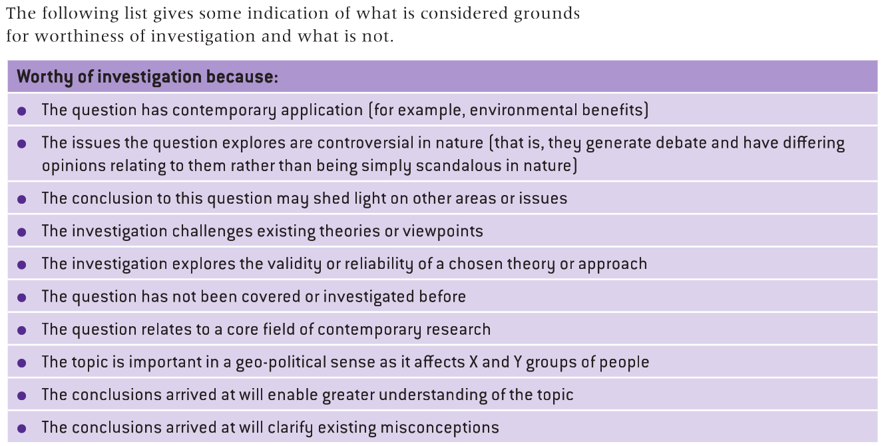
WRITE HERE:

2. Methodology
2.1 General Research Methodology
  - What approach did you take to answer the question.
  - How was data collected (if appropriate)?
  - How did you balance primary and secondary data (if possible)?
  - What sources did you rely on and why?
  - What sources did you exclude and why?
  - What flaws exist in your methodology?
GUIDANCE PAGE: Body Structure, Reporting Verbs & Linking Words
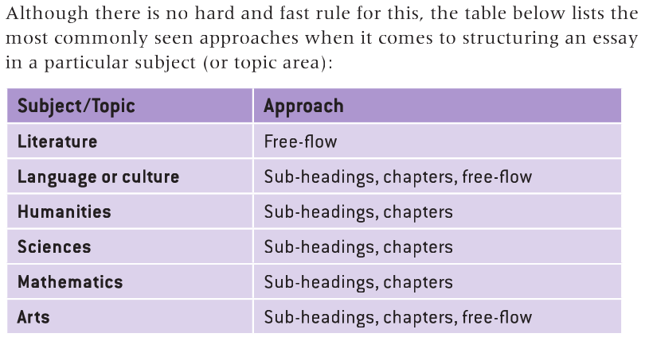
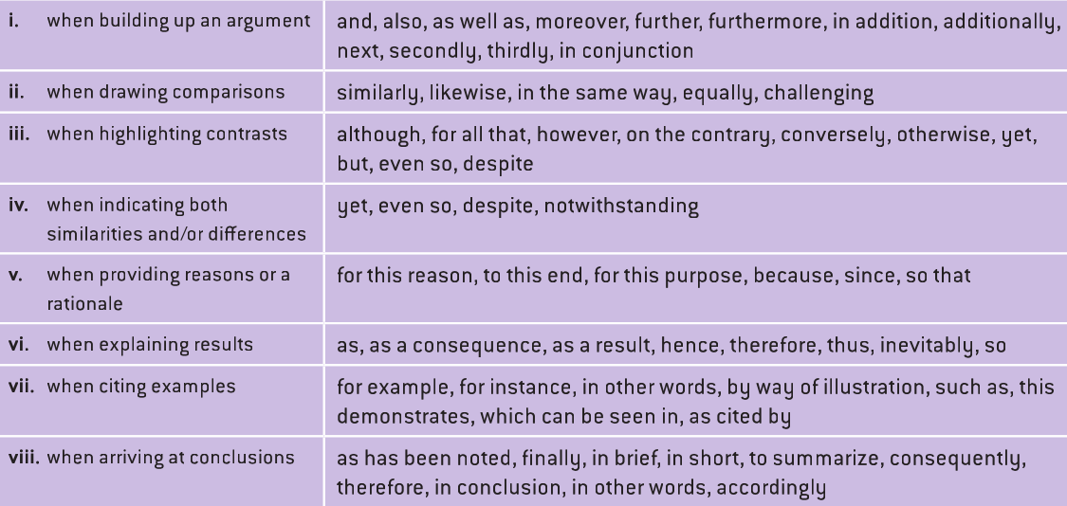
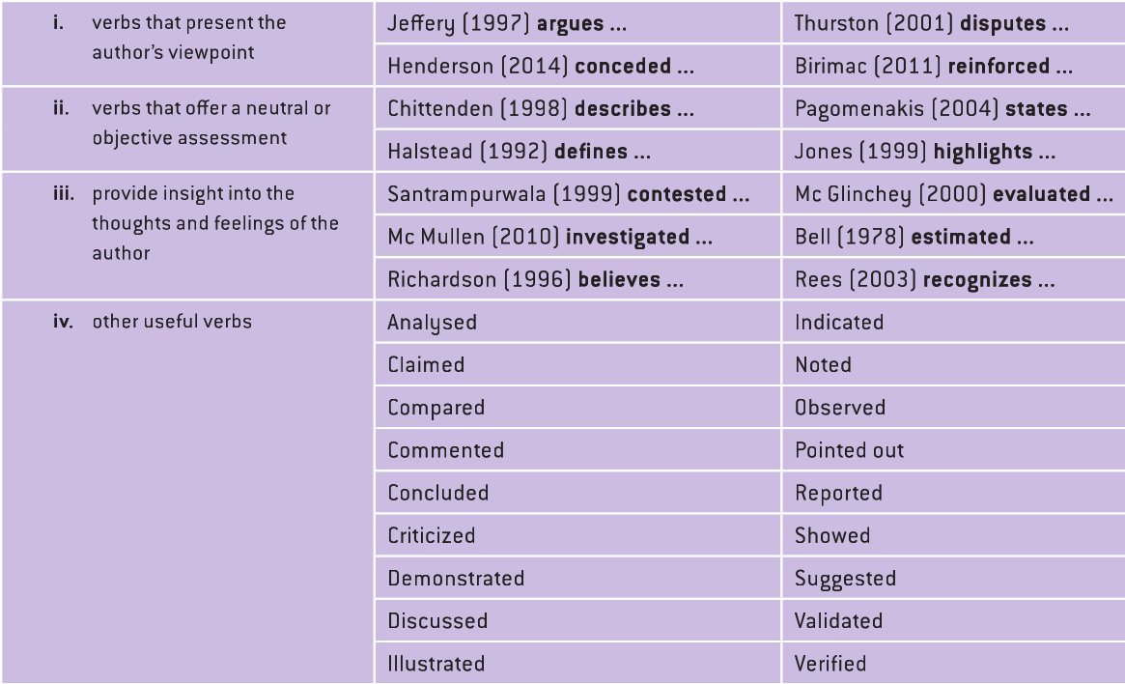
3.1 ‘Section Heading’
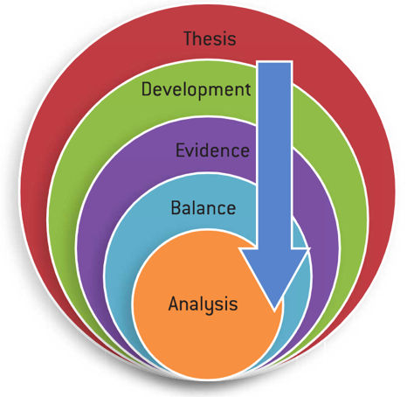
Thesis Statement/Topic Sentence:
- What is the point/issue to be addressed in this section?
WRITE HERE:
Development:
- Explain the thesis statement in greater detail.
WRITE HERE:
Evidence/Events/Examples:
- Provide evidence to support your sub-argument.
WRITE HERE:
Balance:
- Offer an opposing argument to show multiple perspectives, followed by a counter-argument to enforce your point.
WRITE HERE:
Analysis:
- How does the above information link back to your topic sentence and core research question?
WRITE HERE:
3.2 ‘Section Heading’
Thesis Statement/Topic Sentence:
- What is the point/issue to be addressed in this section?
WRITE HERE:
Development:
- Explain the thesis statement in greater detail.
WRITE HERE:
Evidence/Events/Examples:
- Provide evidence to support your sub-argument.
WRITE HERE:
Balance:
- Offer an opposing argument to show multiple perspectives, followed by a counter-argument to enforce your point.
WRITE HERE:
Analysis:
- How does the above information link back to your topic sentence and core research question?
WRITE HERE:
3.3 ‘Section Heading’
Thesis Statement/Topic Sentence:
- What is the point/issue to be addressed in this section?
WRITE HERE:
Development:
- Explain the thesis statement in greater detail.
WRITE HERE:
Evidence/Events/Examples:
- Provide evidence to support your sub-argument.
WRITE HERE:
Balance:
- Offer an opposing argument to show multiple perspectives, followed by a counter-argument to enforce your point.
WRITE HERE:
Analysis:
- How does the above information link back to your topic sentence and core research question?
WRITE HERE:
3.4 ‘Section Heading’
Thesis Statement/Topic Sentence:
- What is the point/issue to be addressed in this section?
WRITE HERE:
Development:
- Explain the thesis statement in greater detail.
WRITE HERE:
Evidence/Events/Examples:
- Provide evidence to support your sub-argument.
WRITE HERE:
Balance:
- Offer an opposing argument to show multiple perspectives, followed by a counter-argument to enforce your point.
WRITE HERE:
Analysis:
- How does the above information link back to your topic sentence and core research question?
WRITE HERE:
3.5 ‘Section Heading’
Thesis Statement/Topic Sentence:
- What is the point/issue to be addressed in this section?
WRITE HERE:
Development:
- Explain the thesis statement in greater detail.
WRITE HERE:
Evidence/Events/Examples:
- Provide evidence to support your sub-argument.
WRITE HERE:
Balance:
- Offer an opposing argument to show multiple perspectives, followed by a counter-argument to enforce your point.
WRITE HERE:
Analysis:
- How does the above information link back to your topic sentence and core research question?
WRITE HERE:
Conclusion
- Summarise key points raised in the main body.
WRITE HERE:
- Synthesis key points into a final analysis.
WRITE HERE:
- Answer your research question.
WRITE HERE:
- Acknowledge limitations and possible future research opportunities.
WRITE HERE:
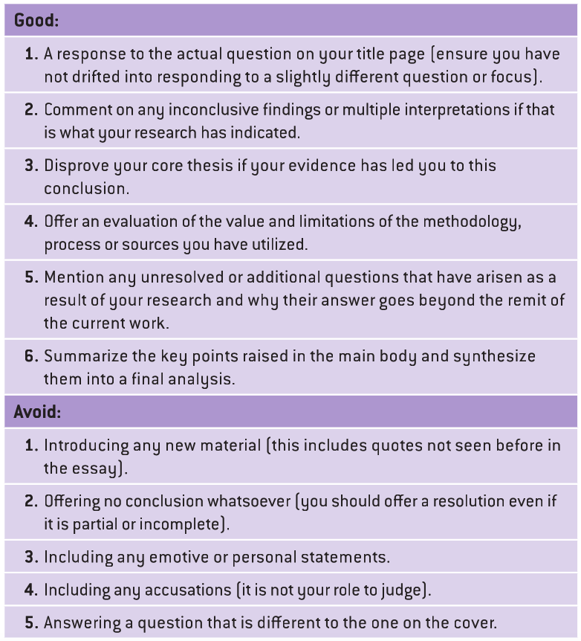

Works Cited (Alphabetical order)
- Use Easybib/Noodletools
- Double-check against ‘MLA 9th Edition’ guidelines (Google, Library and Next Page)

Examples:
Author Last Name, First Name. “Title of Article.” Journal Title, vol. #, no. #, year, page number(s). Database Title, DOI (if available) or URL (without http://) or Permalink. Access Date.
1st Author Last Name, First Name, Second Author First Name Last Name. “Title of Article.” Journal Title, vol. #, no. #, year of publication, page number(s). Database Title, DOI (if available) or URL (without http://) or Permalink. Access Date.
Author’s last name, First name. Title of the Book. Publisher, Year published. Title of Website or database, URL.
Author’s Last name, First name. “Title of chapter or section.” Title of the Book, edited by First name Last name, Publisher, Year published, page number(s).
Author’s Last name, First name. “Title of the Article or Individual Page.” Title of the Website, Name of the Publisher, Date of Publication in Day Month Year format, URL.
Last name, First name, and First Name Last Name. “Title of Webpage.” Title of Website, Publisher, Date Published in Day Month Year format, URL.
First listed author’s Last name, First name, et al. “Title of Web Page.” Title of Website, Publisher, Date published in Day Month Year format, URL.

GUIDANCE PAGE
