League of Nations Dispute 1920

**The Åland Islands**

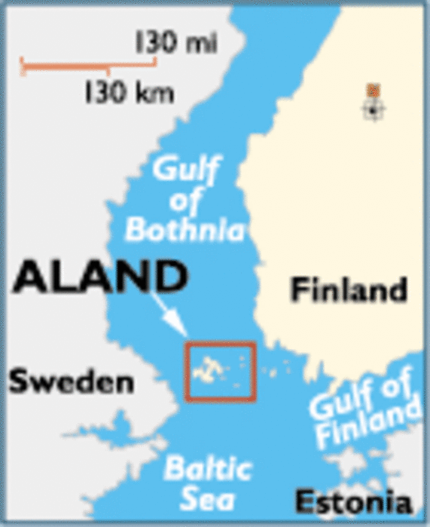

**Disputers**

Sweden and Finland

Size

1527 km2

300 inhabitable Islands

Capital

Mariehamn (50km from Sweden and 70km from Finland)

Population

25,000

(90% Ethnically Swede)

History

  Was part of Sweden until 1809, when it was occupied by Russia and added to their Empire.

  In December 1917, Finland declared itself to be independent from the Russia.

⬥ The Aland Islanders asked for annexation by Sweden, 95% of the population vote for this and it is presented to the Swedish Government on 27 November.

⬥ In January 1918 a Civil War breaks out in Finland between Communist and Non-Communists. The Russian sailors stationed in the Islands refuses to hand them over to the non-Communist Finnish Government.

⬥ Sweden remains neutral in the Civil War and refuses to support either side.

⬥ Sweden sends a Naval Mission to evacuate anyone who wishes to leave.

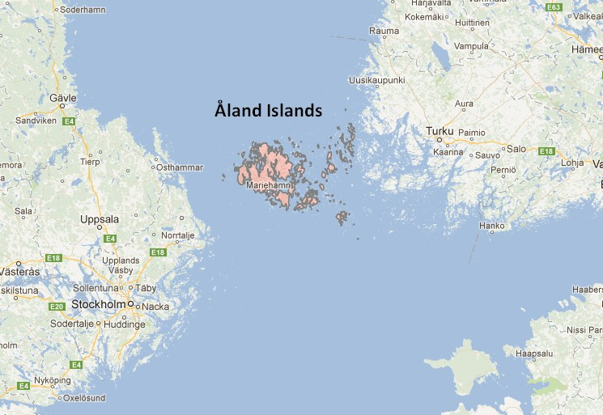

 The Naval Mission does not leave and instead brokers a peace agreement on the island. The commander, then keeps the troops on the island as a peace keeping force.

 The Finnish Government sends a request to the Germans to remove the Swedes.