League of Nations Dispute 1924

**Mosul**

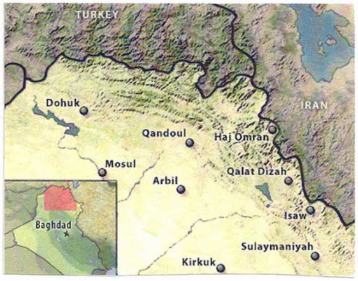

**Disputers**

Britain and Turkey

Size

37000 km2

Population

703,000

(Majority Kurdish)

History

  The province had been seized as part of the Iraq mandate of Britain in 1920 created by the Treaty of Sevres.

At the negotiations at Lausanne, Mosul had been a sticking point as Britain was unwilling to cede the territory from its mandate. In the end it was decided that an international commission should assess the disputed claims to the region, if this was not achieved within nine months then it would be arbitrated by the League.

  Britain regarded the area as geographically distinct from Turkey as it was separated by a mountain range that rose up to 4168m. The area was rich in oil, which has been pointed to as the main reason for the British interest in the region. This is true, but it was not the only factor. Britain felt that Iraq could not be a viable state if it did not have the province, it was the primary stop on the air route from Egypt to India and the Kurdish population wanted to live under British protection. Different parts of the British government had different reasons for securing Mosul.

⬥ Turkey regarded the area as part of their homeland. The British had not actually militarily occupied the area in 1918 and they felt the British had abandoned any moral claims to occupation through their previous support of Greece.

⬥ In 1923 it was decided that Iraq would become an independent state by 1930 and would be admitted to the League of Nations.

⬥ France had little interest in supporting the British as they were angry after the lack of British help in the Ruhr.

⬥ Turkey proposed a plebiscite, but Britain objected as most of the Kurdish population were nomadic and would not be able to vote.

⬥ In August 1924, Britain referred the matter to the League of Nations to resolve.

