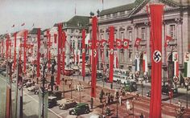**How and Why Did Hitler rearm Germany Between 1933-1936?**

In 1933, within three weeks of gaining power Hitler called meetings with his Generals and Big Business. What do you think he said to each?

Generals: __________________________________________________________________________________________________________________________________________________________________________________________

Big Business: __________________________________________________________________________________________________________________________________________________________________________________________

Average Incomes of Selected Countries in the 1930’s

|  |  |
| --- | --- |
| **Country** | **Average Income (US$)** |

|  |  |
| --- | --- |
| USA | 5,963 |
| Switzerland | 5,922 |
| Netherlands | 5,289 |
| Britain | 5,287 |
| Australia | 5,091 |
| Denmark | 5,006 |
| New Zealand | 4,839 |
| Belgium | 4,832 |
| Canada | 4,347 |
| France | 4,287 |
| Germany | 3,762 |
| Austria | 3,314 |
| Italy | 2,934 |
| Bulgaria | 2,736 |
| Czechoslovakia | 2,318 |
| Greece | 2,261 |
| Hungary | 1,796 |
| USSR | 1,461 |
| Romania | 1,239 |
| Poland | 1,204 |

What does this graph tell us about the position of Germany in relation to its major competitors?

__________________________________________________________________________________________________________________________________________________________________________________________

Why do you think Germany was so poor?

__________________________________________________________________________________________________________________________________________________________________________________________

__________________________________________________________________________________________________________________________________________________________________________________________

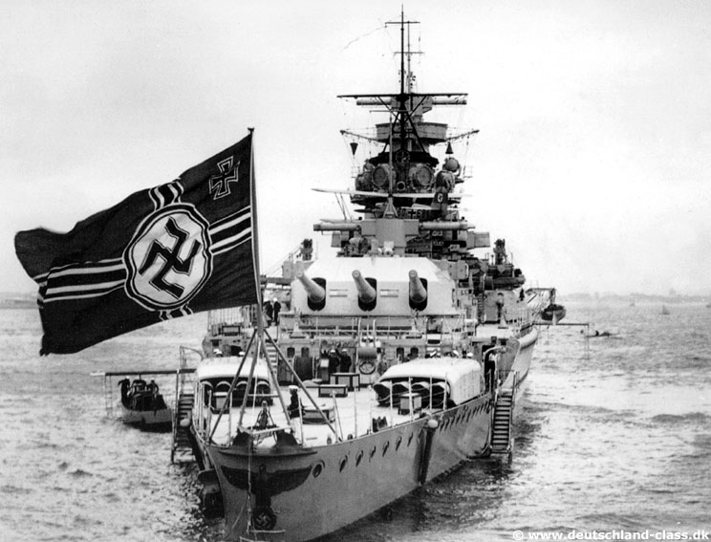On the 8 June 1933, it was decided that Germany would spend an additional 35 billion Reichsmarks on the military over the next 8 years, which would mean that Germany would spend between 7 and 10% of its GDP on defense (China currently spends 2% of its GDP on defense). Plans were made to expand the army to 21 divisions of 300,000 soldiers by 1937 (it would be 43 divisions of 600,000 soldiers by 1936) and a frontline air force of 2,000 planes. Hitler was reluctant to engage in a war with Britain, but by March 1934 he was convinced to undertake a massive increase of the size of the Navy; this included 3 Aircraft carriers and 72 U-Boats, which were completely forbidden by Versailles.

How will Germany rearm from such a comparatively weak financial position?

__________________________________________________________________________________________________________________________________________________________________________________________

__________________________________________________________________________________________________________________________________________________________________________________________

What was the Anglo-German Naval Agreement of 1934 and why did Hitler sign it?

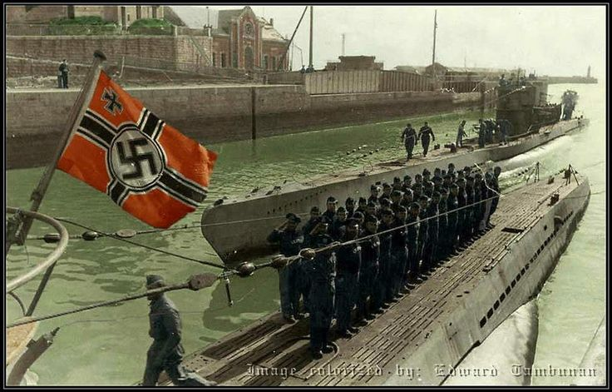

* 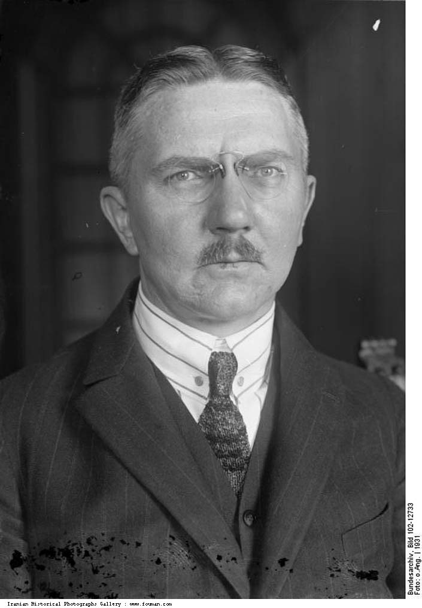The Nazis under Schacht were forced to micromanage the economy in order to ensure they had enough foreign currency in order to import the raw materials that they required to rearm.
* 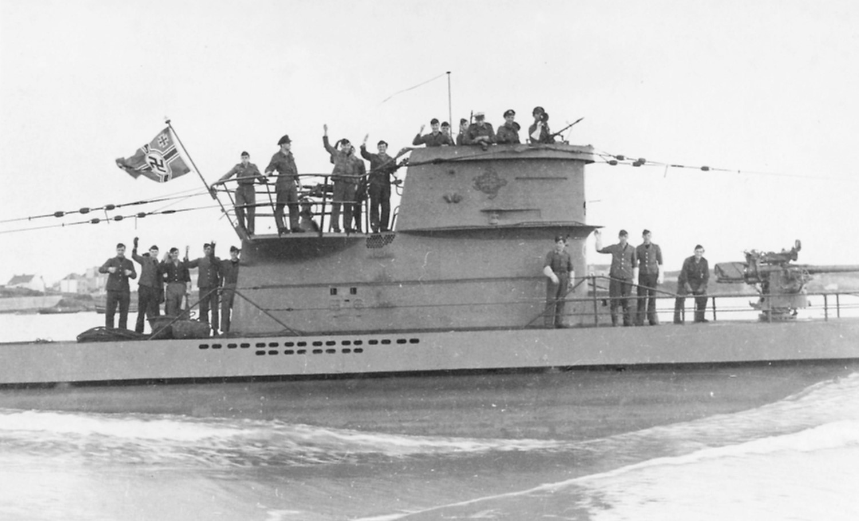The German people were the ones who suffered. Living conditions were surprisingly low. Over 62% of German families reported an income of 30 Reichsmarks a week or less. When you consider that a pair of shoes cost 10 Reichsmarks or 250 grams of butter or a litre of beer was one Reichsmarks you can see that there was little left over for luxury purchases.
* There was very little to buy in the shops anyway, visitors to the Olympic Games in 1936, were shocked at the lack of variety in Berlin stores. It was almost impossible to buy any foreign goods.
* German foreign currency reserves remained dangerously low throughout the 1930’s, the Jews leaving Germany and taking their possessions with them made this worse (eventually the Jews could only exchange their wealth for Palestinian Pounds once they arrived there). In order to pay for the raw materials that they needed, extreme tariffs were placed on foreign goods and Germans were unable to effectively leave the country as they could only carry a maximum of US$10.
* The Reichsmark remained the only major currency that was still tied for Gold. Hitler wanted to keep the Reichsmark strong both for prestige and to reduce the cost of the purchase of raw materials. This meant that German exports were increasingly uncompetitive, but with foreign competitors effectively unavailable, German consumers were forced to pay high prices for all consumer goods.

How does restricting consumer consumption benefit a military build up?

_______________________________________________________________________________________________________________________________________________________________________________________________________________________________________________________________

If Living Conditions were so bad why did the people of the Saar vote to rejoin Germany in 1935?

What did this mean for Hitler?

* 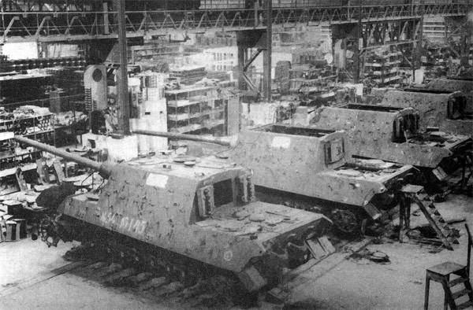Hitler actually used his recklessness to his advantage. As he threatened to default on his debt and there seemed no way he could get the currency needed, the value of German bonds on Wall Street plummeted. German exporters were instructed to buy these devalued bonds on the assurance that profit will be made on them.
* Hitler began to default on German debts beginning in 1934, he was taking advantage of the fact that in the Depression no country could afford an outright German default. The Netherlands, Switzerland and Britain also signed individual deals with Hitler to reduce the German debt. Hitler was then able to default outright on the US$900 million, that he owed the USA. This freed up vast sums for rearmament, yet there was little the USA could do, there was already a trade imbalance of 1200 Million Reichsmarks between the countries, so blocking German exports made no difference and German simply gained the Raw Materials it needed from South America.

How is the flouting of international finance rules preparing for German Rearmament?

_______________________________________________________________________________________________________________________________________________________________________________________________________________________________________________________________

* Hitler also allowed big business to form cartels to control prices and reduce competition, which increased profits which could then be used as loans back to the government.
* 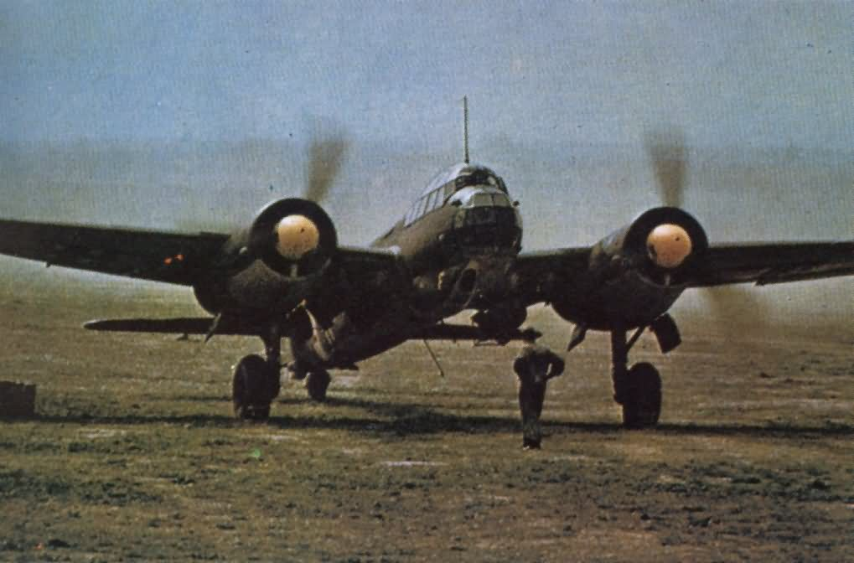These loans could not be on the governments books as if the true nature of German borrowing was revealed it could trigger a collapse in the Reichsmark and alert the world to the scale of Nazi Rearmament. Instead the loans were made to dummy corporations (Mefo Bills) set up by the German Government.
* In order to reduce imports and ensure self sufficiency for war, Hitler instructed IG Farbin to begin building synthetic oil and rubber plants, the price of oil to be sold would be guaranteed by the government up to 5%. This would provide Hitler with the 350,000 tonnes of oil needed for his new Luftwaffe and Panzers by 1936.
* As German policies began to result in higher tariffs on its exports, the Nazi’s placed a 2% tax on the gross production of all factories that was then used to subsidise German exports.
* The textile industry accounted for 24% of German imports as these were not needed for rearmament, Schacht restricted the amount of time factories were open and limited production. He also ordered the development of factories that could make clothes synthetically.

How is the reorganization of German Business being redesigned for a Rearmament?

_______________________________________________________________________________________________________________________________________________________________________________________________________________________________________________________________

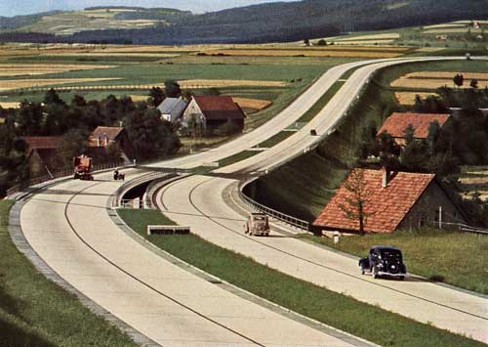

* In 1932 the German Aircraft industry employed 3,200 people, less than two years later it employed over 54,000 and produced 2,500 planes a year. It is important to realise that none of the expansion was for any civilian aircraft it was entirely military production.
* Most Germans did not understand that the rearmament was a drain on their standard of living and the mass spectacles of rearmament at rallies such as Nuremberg were extremely popular. Many workers had an affinity with the weapons that they were producing and there was almost uniform support for the reintroduction of conscription in 1935.
* In 1933, Hitler began the Autobahn project. A nationwide system of motorways seems strange for a country with 1.5 cars for every 100 people (most of these were used for businesses), but it was intended primarily for wartime use, the quick movement of troops across the country. Budgetary restrictions meant that the plan was never fully realized with only 38,000 workers ever employed at any one time.
* In 1935 the Reinhardt program to reduce unemployment was cancelled, from now on all state intervention to reduce unemployment will be through rearmament.

How is this Rearmament both a success and a failure for Germany?

_______________________________________________________________________________________________________________________________________________________________________________________________________________________________________________________________

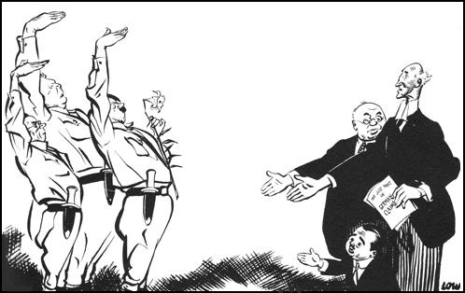__________________________________________________________________________________________________________________________________________________________________________ _____________________________________________________________________________________

Why did Hitler leave the Disarmament Talks and League of Nations on 14 October 1933?