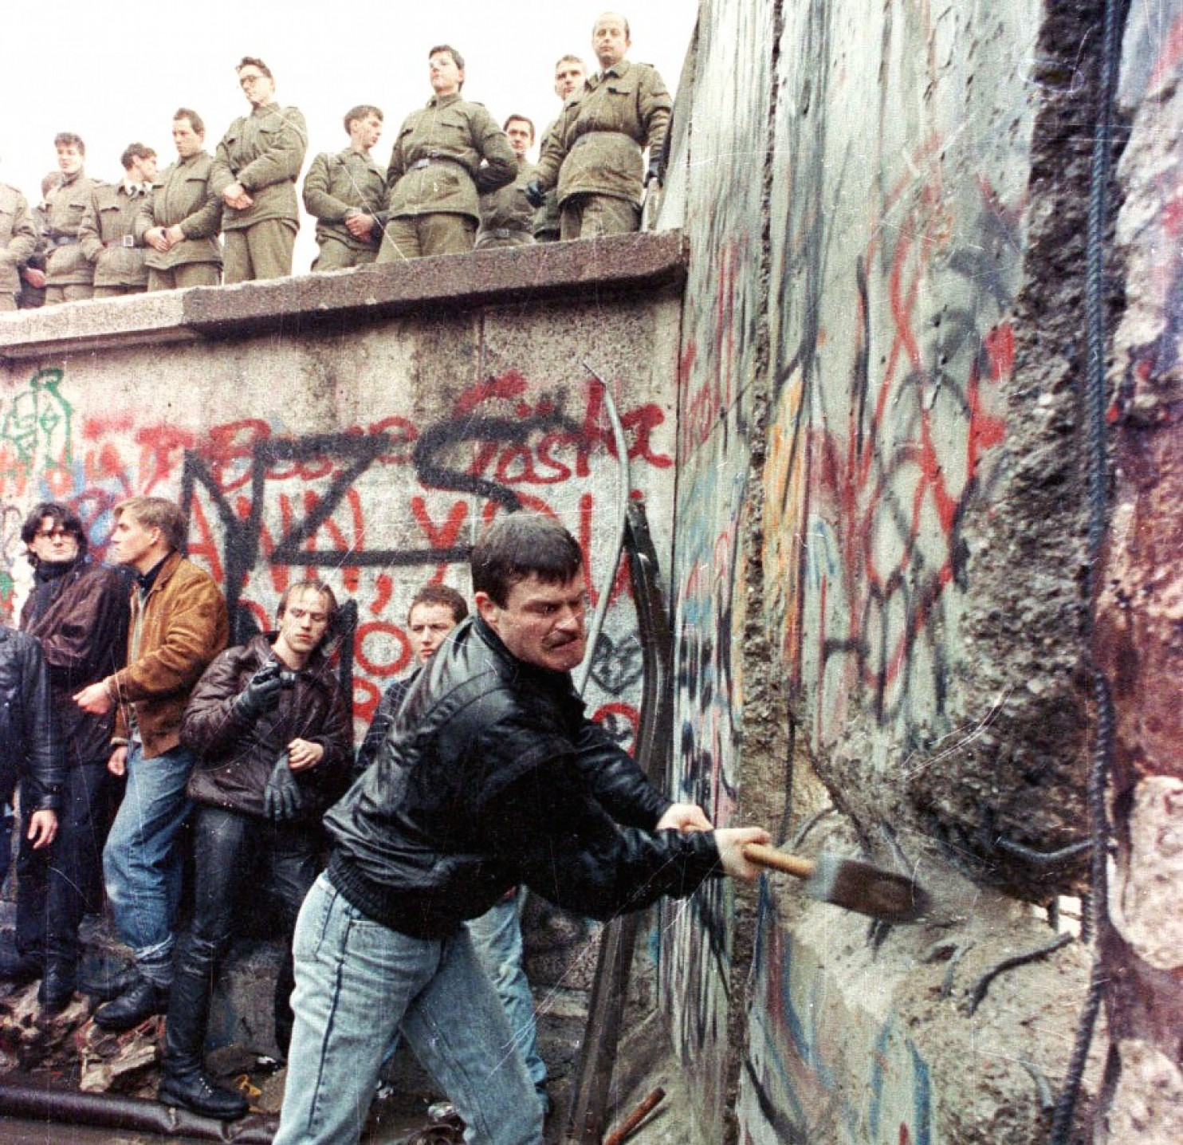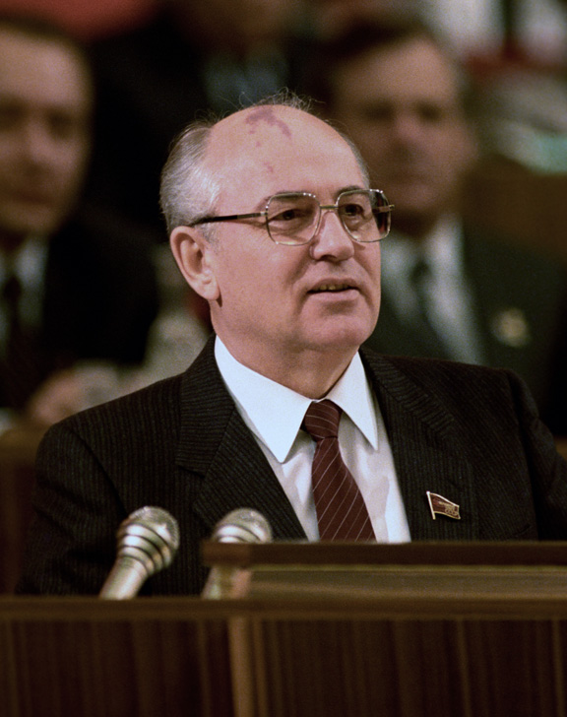Fall of Communism in Eastern Europe

What did Gorbachev get right and what did he get wrong?

Why was Hungary the first to reject Communism and how did they do it?

How were the Pole’s different from rest of the Bloc why did this happen?

Who was opposing the reforms in the Warsaw Pact and why?

What was the importance of Jackson Holt?

What were the problems in the GDR?

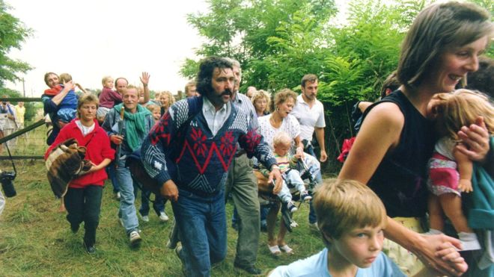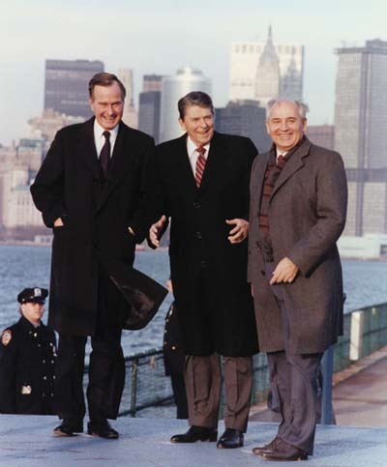

What role did Helmut Kohl and the Hungarians play?

How was the Czechoslovakian Refugee Crisis resolved?

Why was the GDR losing its nerve?

What was the turning point in the GDR?

What was the matter with Egon Krenz?

How did confusion bring down the Berlin Wall?

‘

16:15 -17:15

31:45